Document A: Textbook
Qin Shi Huang imposed a new order on China. He ended the power of the local lords by taking land from many of them and imposing a tax on landowners. He appointed educated men instead of nobles as officials to run his government.
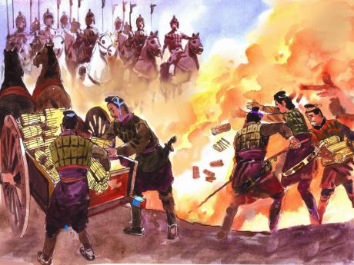
Qin even imposed censorship, clamping down on scholars who discussed books and ideas. In 213 B.C.E he ordered all books burned except those about “practical” subjects like agriculture, medicine, and magic. In this way he hoped to break people’s ties to the past so they would not criticize the present. About 460 scholars resisted and were executed.
Qin’s subjects saw him as a cruel tyrant who had lost the Mandate of Heaven. Nobles were angry because he had destroyed the aristocracy; scholars detested him for the burning of books; and peasants hated his forced-labor gangs. In 210 B.C.E Qin died, and soon the dynasty itself came to an end. Even so, the rule of the Qin established foundations for the Chinese state that would last 2,000 years.
In 207 B.C.E. Liu Bang overthrew the Qin. A military official from a peasant background, Liu defeated his most powerful rival in 202 B.C. and declared himself the emperor of a new dynasty, the Han. The Han governed China until C.E. 220, more than 400 years. The Han emperors used Qin forms of centralized power, but without the harshness of Qin rule.
Source: Farah & Karls, World History: The Human Experience, (New York: Glencoe McGraw-Hill, 2001).

Vocabulary
tyrant: a cruel and unfair ruler
Mandate of Heaven: ancient Chinese belief that monarchs received their power to rule from heaven aristocracy: a form of government in which power is held by a small group of privileged individuals

STANFORD HISTORY EDUCATION GROUP sheg.stanford.edu
Document A: Textbook
Qin Dynasty Guiding Questions
1. According to the textbook, what reforms did Qin Shi Huang enact during his reign?

2. According to the textbook, how did Qin’s subjects react to his reforms?

3. Why is it important to keep the aristocracy (nobles/upper class) pleased for any government or ruler?

Document B: Confucian Essay
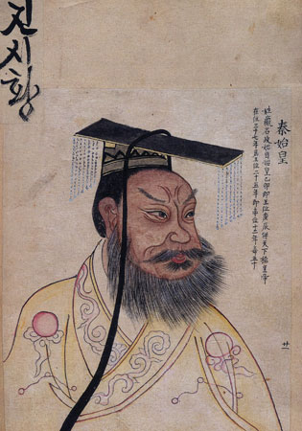
Jia Yi was a Confucian poet and statesman of the Han dynasty who lived from approximately 200 to 168 BCE. Below are excerpts from his essay “The Faults of Qin.”
Chen She was a man who grew up in humble circumstances . . . and was a mere hired field hand and roving conscript of mediocre talent. . . . Yet, even stumbling as he did amidst the ranks of common soldiers and shuffling through the fields, he called forth a tired motley crowd and led a mob of several hundred to turn upon the Qin. . . . They had the whole world come to them like gathering clouds. . . . These men of courage from the East rose together, and in the end they defeated and extinguished the House of Qin. . . .
Chen She’s weapons made of farm implements and thorny tree branches were no match in battle against spears and halberds, his roving conscripts in no way compared to the armies of the nine states. . . . Qin, from a tiny base, had become a great power, ruling the land and receiving homage from all quarters for a hundred-odd years. Yet a single common person could nevertheless challenge this empire and cause its ancestral temples to topple and its ruler to die at the hand of others, a laughing-stock in the eyes of all. Why? Because the ruler lacked humaneness and rightness; because preserving power differs fundamentally from seizing power. . . .
Had the Second Emperor been even a mediocre ruler who knew how to employ local and capable persons . . . ; had he divided the land and appointed deserving officials . . . ; had he emptied the prisons and reduced harsh punishments . . . ; had he only reduced taxation and statutes to alleviate oppression . . . ; had he indeed fulfilled the wishes of the multitudes and bestowed high virtue on them, he would have certainly brought peace and quiet to the world.
Source: Jia Yi, “The Faults of Qin.”
Vocabulary
conscript: someone who is required to join the military halberd: a weapon that is a combined spear and battle ax homage: respect or honor
STANFORD HISTORY EDUCATION GROUP sheg.stanford.edu
Document B
1. Who was Jia Yi? How long after the fall of the Qin Dynasty was this document written?

2. The rebel leader Liu Bang founded the Han dynasty in 206 BCE. Jia Yi was a statesman of the Han dynasty. How might this have affected Yi's account of the fall of the Qin?

3. Under the Qin, the philosophy and scholars of Confucianism were persecuted. At the beginning of the Han dynasty, the imperial court accepted both Legalism and Confucianism. How might this have affect Yi's account?

Document C: Newspaper Article
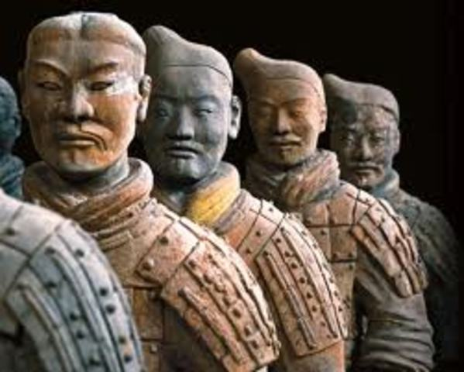
The following newspaper article was written in China during the Cultural Revolution (1966-1976 CE), a time of very severe government censorship. People who criticized the government were often punished by the state. The article’s author analyzes Confucian criticism of Qin and the fall of the empire.
On the question of the causes of the downfall of the Qin dynasty, the first fallacy fabricated by the reactionary Confucian scholars was the “theory that the Legalist line destroyed Qin.” . . .
Actually the opposite was true. Originally, Qin was a small feudal state in the western part of China. Until the early years of the Warring States period, it was still rather backward, and was looked upon by the various eastern states as a “barbarian” country. Later, Qin . . . implemented the Legalist line and, as a consequence, rapidly became strong and prosperous. Qin Shi Huang was an outstanding statesman of the Legalist school. Within a short period of time he unified the six states and established the first centralized feudal state. . . .
However, Qin Shi Huang had one great flaw: he did not strike at the opposition hard enough, or suppress them thoroughly. After the establishment of the Qin dynasty, he forcibly moved 120,000 influential and wealthy families from all parts of the country to Xiangyang, thus forcing them to move far away from their old homes . . . But the Qin government did not adopt effective measures for exercising dictatorship over these reactionary slave owners.
Source: T’an Hsiao-Wen, “A Refutation of Some Confucian Fallacies Concerning the Causes of the Downfall of the Ch’in Dyansty,” Kuang-ming jih-pao (Enlightenment Daily), September 1, 1974, Beijing.
Vocabulary
fallacy: a false idea fabricated: made up
STANFORD HISTORY EDUCATION GROUP sheg.stanford.edu

Document C
1) When was this document written? What was this time in Chinese history like? (see document description)

2) How might this have influenced what Hsiao-Wen wrote about the fall of the Qin Dynasty? What does Wen accuse Shi Huangdi of not doing?

3) Why do you think the author of the article wrote that Confucian scholars had "fabricated a fallacy"?

