Decline and Fall of the Abbasid (Islamic) Caliphate
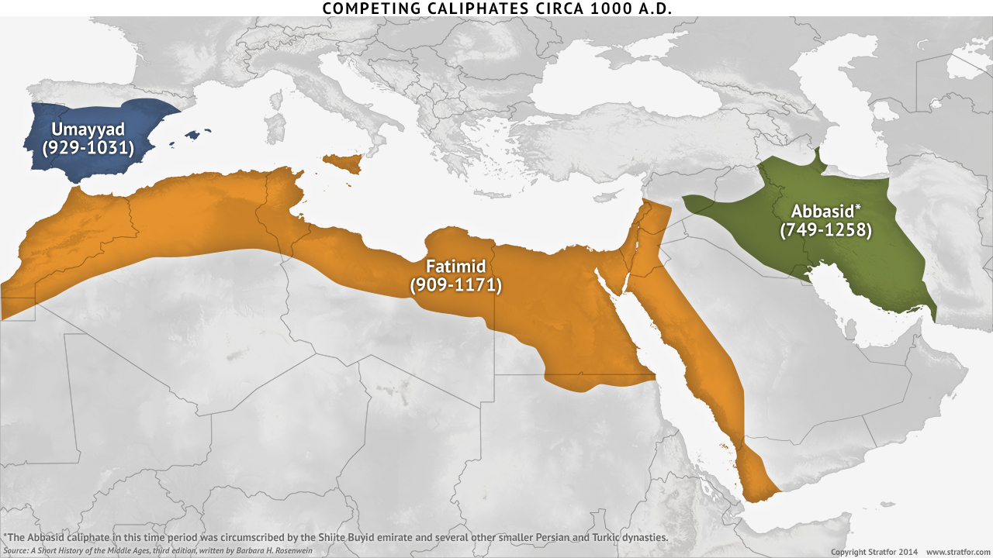
...After the caliphate of al-Ma’mun (833 CE), Abbasid power began to noticeably decline. The cost of running a massive empire and maintaining a large bureaucracy required steady revenues, and as the authority of the caliphate diminished it was able to collect fewer taxes. In order to stabilize the state finances, the caliphs granted tax-farms to governors and military commanders. These governors, with their own troops and revenue bases, soon proved independent-minded and disloyal.
From this point on, the Abbasid caliphs became little more than religious figureheads. In the mid-11th century, the Buyids were ousted by the Sunni Seljuq Turks, who conquered Iran, Iraq, Syria, and most of Asia Minor, forming a new and vibrant Islamic Empire. The Seljuqs continued to keep the Abbasid caliph as the titular ruler while exercising true authority over the empire as sultans.
The End of the Abbasids
When the Seljuq sultanate collapsed in the twelfth century, an opportunity presented itself for Caliph al-Nasir (r. 1180–1225) to attempt to restore Abbasid power in Iraq. His long reign of forty-seven years allowed him ample time to reconquer Mesopotamia and further develop Baghdad as a center of learning. His chief rival was the Sultanate of Khwarezm, which ruled Persia. Supposedly, al-Nasir appealed to the Mongols, an expanding central-Asian nomad empire, for help against Khwarezm. Under al-Nasir’s less competent successors, this backfired disastrously. The Mongols completely overran Khwarezm and then turned their attention to Baghdad.
The Mongols seem to have wanted to rule by holding real military power but allowing the Abbasid caliph symbolic authority. Caliph al-Mu`tasim (r. 1242–1258), however, refused to acknowledge their authority and offered these non-Muslims only insults and threats. Faced with Mongol invasion, he did little to prepare, and the Mongol hordes soon surrounded Baghdad. They captured the city in 1258 and sacked it. They trampled the caliph to death, and completely destroyed the city. They killed somewhere between 100,000 and a million people, destroyed all the books of the House of Wisdom and other libraries, burned down all the great monuments of the city, and left Baghdad a smoldering ruin. This marks the end of the Abbasid caliphate of Baghdad, and the abrupt end of the Islamic golden age. Excerpt from Al-Islam.org

1) Rank the causes of the decline of the Abbasid caliphate (1- ) and explain why you ranked them.

2) Compare the Abbasid caliph's position with that of the emperor in feudal Japan.

3) What effect can you infer the destruction of a city such as Bagdad had on the rest of the Islamic world?

