Extra Credit Research Paper
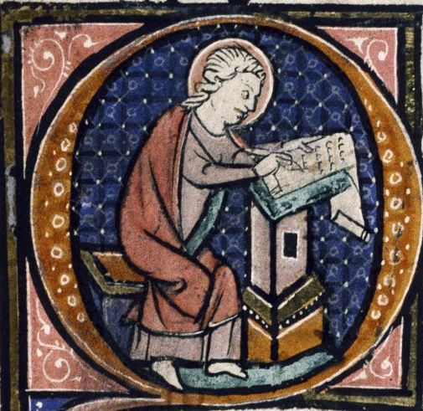

Minimum Length: 4 typed pages (not including bibliography and works cited pages)
Maximum Length: 6 typed pages

NOTE: MUST BE SIZE 12, TIMES NEW ROMAN, REGULAR MARGINS

This assignment is meant both as a preparatory tool for college and a boost for your average (given the assignment is done well). It will require a considerable amount of work: research, outlining, meeting with me at times, and then the actual writing of the paper. But if you follow the check-list below, you will be able to stay on track and produce a paper worthy of a 1000-level college course.

Requirements:

Thesis Statement- all papers must present a thesis statement (a specific argument on a certain topic). This should present the position which you will support. All evidence, arguments, and theories should uphold this position or statement. It should be presented within the first paragraph of your paper.

Parenthetic citations or footnotes - all evidence taken from source materials must be cited. This will include any facts, statistics, quotations or ideas not your own that are used to support your thesis. Remember a thesis paper is an argument. The documents you use are supposed to prove your thesis. The form used in citation is as follows: (Author’s /editor’s last name, page number/s).

Bibliography- You must include a bibliography page at the end of your paper. All outside sources must be presented here. This includes, source books, magazine articles, electronic or traditional encyclopedias. Please check to be certain that you use proper bibliographic form. Example:

Author’s Last Name, First name, Title of Work Editor (if any)
Publisher, Copyright date

Source Materials - You must use five books or published articles (online or hard-copy) to construct your paper. While these five sources should form the foundation of your paper, this does not mean you need to read the entirety of each book; use the index to search for the information you need.

Websites do not count as sources: published sources accessed digitally (JSTOR, Proquest, etc.) are acceptable. See me for clarification.

The Paper Itself-This is a research paper. Its sole purpose is to serve as a vehicle for the investigation of a topic. It is not a report. Please do not hand in a book report. I know the history; I need to know your argument and how you are supporting this argument with historical facts and figures. A research paper seeks to prove a thesis by using arguments developed by you and supported by what others have written about the subject..

A good formula to assist in the creation of a thesis statement is:
1) Select at topic - i.e. Genocide

2) Come up with several questions about your topic - i.e. Why did some people survive while others did not? or What causes one group to attempt to destroy another group? or What role does nationalism play in genocide?

3) Research the question and take notes on what you find.

4) The answer to your question should be your thesis statement.

Theoretically, the majority of the research should be done as you are putting together your thesis. If you take proper notes and are organized the actual writing of the paper will go quite quickly.

EXTRA CREDIT POINTS: What the paper is worth is up to you. If I receive a well-researched, well-written paper, then you shall receive 100 assessment averaged into the test/assessment portion of your average. If I receive a poorly-researched, poorly-written paper, then you shall receive a few points on homework or a quiz. It is up to YOU.

See me for an assignment date and a due date. You will have over a month to do this extra credit assignment, but we must set parameters.

ASSIGNED:

DUE DATE:

Note: some of you may feel more comfortable selecting from a pre-approved list of thesis statements. I have provided a list of acceptable topics below. Some of the topics are modern, and you can consult me regarding sources, but I know some of you have far more interest in 20th century history than that of ancient or medieval history.

List of approved Thesis Statements:

1. The legacy of the ancient Greek culture can still be seen in Europe today.

1a. The Roman army was the finest military force of the ancient world.

2. The fall of the Roman Empire pushed Europe into decline for many centuries.

3a. The Islamic Umayyad and Abbasid caliphates began a Golden Age of learning and culture, while Western Europe remained a backwater for centuries.

3. The Crusades made a major impact on both European and Arabic cultures.

4. The ghost of Machiavellian politics still haunts modern global politics.

5. The Italian Renaissance was fueled by war and conquest.

6. The invention of the movable type printing press led to the Age of Revolution.

7. Religious conflict has been a major force for change throughout the world.

7a. Columbus was a genocidal conqueror who began the devastation of Native American civilization OR Columbus was a noble explorer who was a product of his time and helped create the modern world.

8. The Mongols were a positive/negative force for change in the Asian world.

9. The Pax Mongolia made a greater impact on global development than did the Pax Romana.

10.The Mughal Empire’s attempt to mix Islam and Hinduism ultimately led to its fall.

11. The current importance of Paris in the world of fashion can be traced to the court of Louis XIV.

12. The conquest of the Meso-American and Andean societies was inevitable.

14. The impact of the Western tradition of revolution was a major factor in its political development.

15 The lack of revolution in the east led to its political development.

15a. The Industrial Revolution, while producing our modern world, led to major health, social, and environmental problems we have not resolved to this day.

16. The Nationalism of 19th century led directly to the bloody first half of the 20th century.

17. The imperialism of the 19th century and racism are inseparably linked.

18. The music, art and literature of (pick an era or period) was a mirror for the political events of that period.

19. The Russian Revolution was inevitable.

20. The Meiji Restoration inevitably led to Japanese imperialism and WW II.

21. The Treaty of Versailles set the stage for World War II.

22. Latin American totalitarian dictatorships resulted from European imperialism.

23. Anti-Semitism predates the Holocaust by many centuries.

24. The Allied failure to advance on Germany led to the rise of Cold War.

25. The collapse of Communism in Europe was in inevitable.

26. The rise of terrorism in the Middle East during the 20th century was linked to the legacy of Western colonialism and intervention.

To summarize: You need a 4-6 pages (Intro, thesis, body paragraphs, conclusion) and a bibliography page, in size 12, doubled spaced, Times New Roman, regular margins.

