Edmund Burke: Reflections on the French Revolution
(1790)

III. THE ERRORS OF THE FRENCH REVOLUTION [edited]
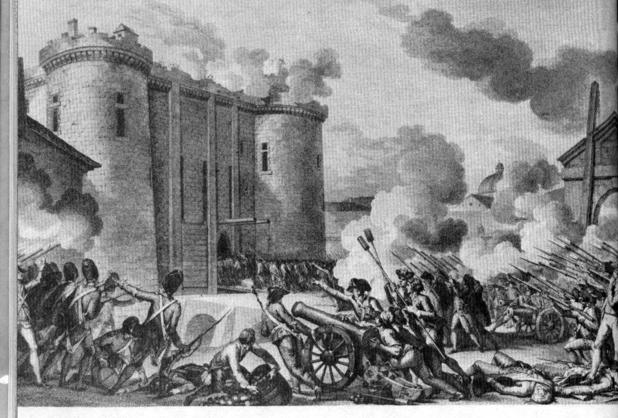

France, by the dishonesty of her leaders, has utterly disgraced the tone of moderate advice in the governments of princes, and disarmed it of its most potent topics. She [France] has blessed the dark, suspicious sayings of tyrannous distrust, and taught kings to tremble... Sovereigns [leaders] will consider those who advise them to place an unlimited confidence in their people as usurpers of their thrones, as traitors who aim at their destruction by leading their easy good-nature, under false pretenses, to allow bold and faithless men into a participation of their power. This alone (if there were nothing else) is an irreparable calamity [disaster] to you and to mankind. Remember that your parliament of Paris told your king that, in calling the states together, he had nothing to fear but the uncontrolled excess of their zeal in providing for the support of the throne. It is right that these men should hide their heads. It is right that they should bear their part in the ruin which their counsel [plans] has brought on their sovereign and their country. Such optimistic declarations tend to lull authority asleep; to encourage it rashly to engage in perilous adventures of untried policy; to neglect those provisions, preparations, and precautions which distinguish benevolence from imbecility, and without which no man can answer for the beneficial effect of any abstract plan of government or of freedom… They have seen the French rebel against a mild and lawful monarch with more fury, outrage, and insult than ever any people has been known to rise against the most illegal usurper or the most sanguinary tyrant.
This was unnatural. The rest is in order. They have found their punishment in their success: laws overturned; tribunals subverted; industry without vigor; commerce expiring; the revenue unpaid, yet the people impoverished; a church pillaged, and a state not relieved; civil and military anarchy made the constitution of the kingdom; everything human and divine sacrificed to the idol of public credit, and national bankruptcy the consequence; and, to crown all, the paper securities of new, precarious, tottering power, the discredited paper securities of impoverished fraud and beggared rapine, held out as a currency for the support of an empire in lieu of the two great recognized species that represent the lasting, conventional credit of mankind, which disappeared and hid themselves in the earth from whence they came, when the principle of property, whose creatures and representatives they are, was systematically subverted.

QUESTIONS
1) What is Edmund Burke's reaction to the French Revolution?

2) According to Burke, what should have the French done when beginning their revolution?

3) Why is the upheaval of the French Revolution negative for the "governments of princes" and the rest of Europe?

4) How does Burke view the now-dead French king? Be specific with your evidence.

