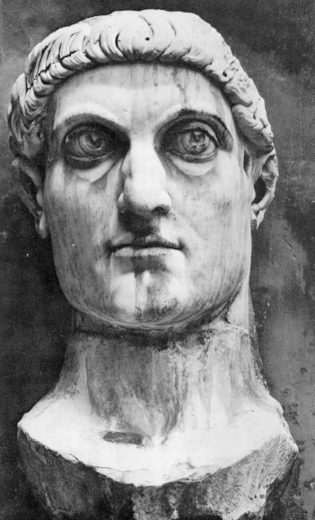
The Edict [declaration of law] of Milan (313 CE)
PART I
When I, Constantine (see picture right), as well as I Licinius [co-emperor] fortunately met near Mediolanum (Milan)... we grant[ed] to the Christians and others full authority to observe that religion which each preferred... that no one whatsoever should be denied the opportunity to give his heart to the observance of the Christian religion, of that religion which he should think best for himself... we have also conceded to other religions the right of open and free observance of their worship for the sake of the peace of our times, that each one may have the freedom to worship as he pleases...

PART II
All this property [that had been taken] ought to be delivered at once to the community of the Christians... without delay. And since these Christians are known to have possessed not only those places in which they were accustomed to assemble, but also other property, namely the churches, belonging to them as a corporation and not as individuals, all these things which we have included under the above law, you will order to be restored, without any hesitation... our command may be carried into effect as quickly as possible, whereby, moreover, through our clemency, public order may be secured.
Let this be done so... [we] may preserve and prosper our successes together with the good of the state...
from Lactantius, De Mort. Pers., ch. 48. opera, ed. 0. F. Fritzsche, II, p 288 sq. (Bibl Patr. Ecc. Lat. XI).
Both texts translated in University of Pennsylvania. Dept. of History: Translations and Reprints from the Original Sources of European history, (Philadelphia, University of Pennsylvania Press [1897?-1907?]), Vol 4:, 1, pp. 28-30

QUESTIONS
1) Summarize the Edict of Milan. What does it do?

2) Would you consider this edict to be tolerant of Christians or respectful towards them? Cite specific evidence.

3) What other measures of religious tolerance can you recall from our class? Be specific.

Constantine ordered a council of all Christian leaders to the city of Nicaea in modern-day Turkey to put down list of the beliefs all Christians should follow, later called the Council of Nicaea (325 CE). Constantine attended the councul but did not interfere in the debate. The list of beliefs created was later named the Nicene Creed and remains as the central text of faith for every Catholic around the world.

1) What effect would having the emperor at this council have on the Christian leaders?

2) If you were a polytheist, what would your reaction be to seeing Constantine attend this council? Why?

