Russia-Early History and Origins

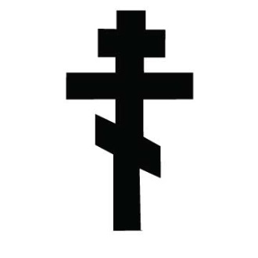
Conversion to Christianity 988 CE

Mongol Isolation (1240-1480)
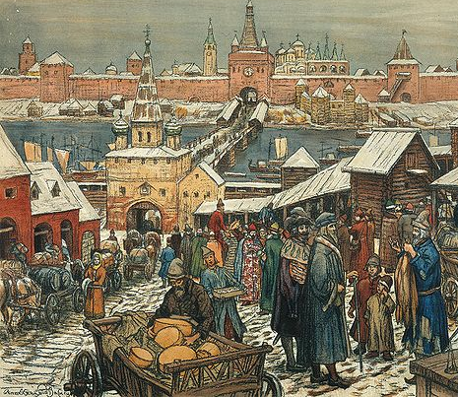
Kiev

Muscovy

Ivan the Great (AKA Ivan III-ruled 1462-1507 CE)

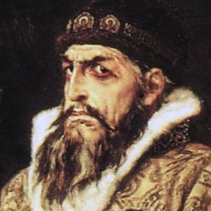

Ivan the Terrible (AKA Ivan IV-ruled 1547-1584 CE)

