Early Hellenistic Culture
"Alexander," from Plutarch's Lives
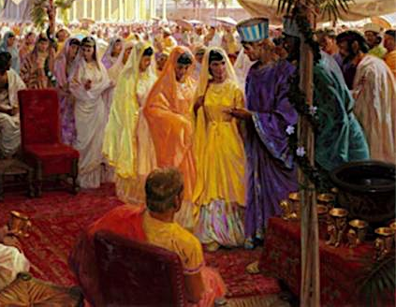
Alexander adapted his own mode of life more to the customs of the country, and tried to bring these into closer agreement with Macedonian customs, thinking that by a mixture and community of practice which produced good will, rather than by force, his authority would be kept secure while he was far away. For this reason, too, he chose out thirty thousand boys and gave orders that they should learn the Greek language and be trained to use Macedonian weapons, appointing many instructors for this work. His marriage to Roxana, whom he saw in her youthful beauty taking part in a dance at a banquet, was a love affair, and yet it was thought to harmonize well with the matters which he had in hand. For the Barbarians [Persians] were encouraged by the partnership into which the marriage brought them, and they were beyond measure fond of Alexander, because, most moderate of all men that he was in these matters, he would not approach to approach even the only woman who ever mastered his affections, without the sanction of law.
QUESTIONS
1) How does Alexander attempt to blend Macedonian/Greek and Persian culture?

2) Why would Alexander wish to do this? How would it effect his empire?

"On the Fortune of Alexander"
For Alexander did not follow Aristotle's advice to treat the Greeks as if he were their leader, and other peoples as if he were their master ; to treat the Greeks as friends, but to conduct himself toward other peoples as though they were plants or animals [beneath him]; for to do so would have been to burden his leadership with numerous battles and banishments and festering seditions [rebellion]. But, as he believed that he came as a heaven-sent leader for all, and as a mediator for the whole world, those whom he could not persuade to unite with him, he conquered by force of arms, and he brought together into one body all men everywhere, uniting and mixing in one great loving-cup, as it were, men's lives, their characters, their marriages, their very habits of life.⁴⁰ He ordered them all to consider as their country the whole inhabited earth, as their stronghold and protection his camp, as akin to them all good men, and as foreigners only the wicked; they should not distinguish between Greek and foreigner by Greek cloak and shield, or sword and jacket; but the distinguishing mark of the Greek should be seen in virtue, and that of the foreigner in evil ; clothing and food, marriage and manner of life they should regard as common to all, being blended into one by ties of blood and children.

Alexander at the gates of Babylon

I [Plutarch, the historian] would gladly have been a witness of that fair and holy marriage-rite, when he brought together in one golden-canopied tent a hundred Persian brides and an hundred Macedonian and Greek bridegrooms, united at a common hearth and board.⁴³ He himself, crowned with garlands, was the first to raise the marriage hymn as though he were singing a song of truest friendship over the union of the two greatest and most mighty peoples ; for he, of one maid the bridegroom, and at the same time of all the brides the escort, as a father and sponsor united them in the bonds of wedlock. Indeed at this sight I should have cried out for joy, ‘O dullard Xerxes, stupid fool that spent so much fruitless toil to bridge the Hellespont! This is the way that wise kings join Asia with Europe ; it is not by beams nor rafts, nor by lifeless and unfeeling bonds, but by the ties of lawful love and chaste nuptials and mutual joy in children that they join the nations together.’
QUESTIONS
1) How does Alexander attempt to blend Macedonian/Greek and Persian culture?

2) Why would Alexander wish to do this? How would it effect his empire?

3) How do Alexander's actions demonstrate cultural diffusion and Hellenistic culture?

