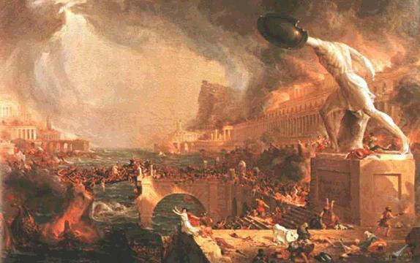
DECLINE AND FALL OF THE ROMAN EMPIRE

Lesson Plan (2 days)
After Pax Romana, (ends roughly 180 CE), Rome begins to go into decline. Western Empire falls in 476 CE. WHY? Slow death or murder?

1. 3rd Century Crisis

2. Barbarian Invasions

3. Economic Decline

4. Mercenaries and Traitors

5. Christianity

6. East-West Split?

Procedure:
1) Group work at stations, taking approximately 10 minutes per station

2) Students read passages, and fill out the fishbone diagram. Students will place evidence under social, political, religious, and economic causes.

3rd Century Crisis

The period of the Pax Romana ("Roman Peace", traditionally 29 BCE to 180 CE) was a time of prosperity and relative stability. Some emperors abused their power, murdering political opponents and wasting the resources of the empire on luxury for themselves. Civil wars occasionally broke out (Year of the Four Emperors, 69 CE) but, as a whole, the 200 years after Augustus became emperor in 29 BCE were largely peaceful, as trade flourished, the empire expanded, and some of the greatest structures the world has ever seen were built.
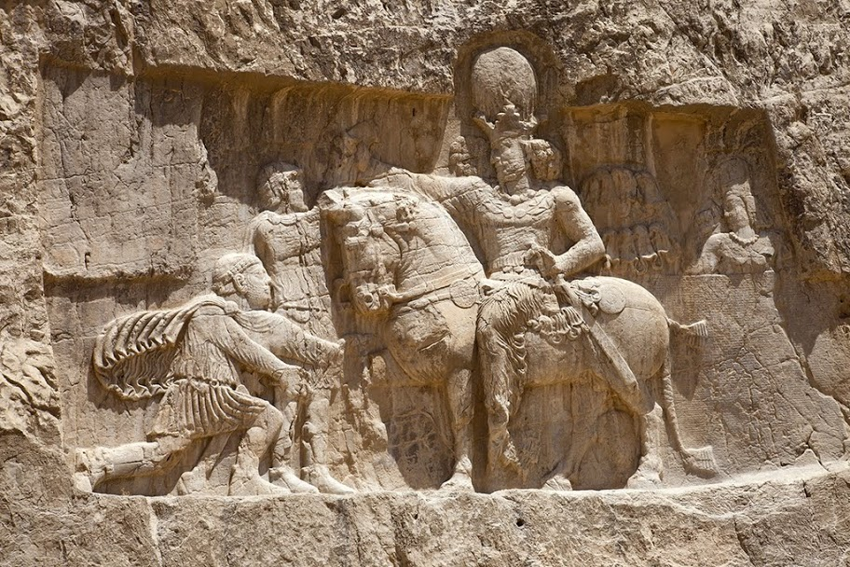
But after the reign of the Five Good Emperors (96 CE-180 CE), this all began to change. During what is now known as the "3rd century Crisis", the fortunes of Rome turned for the worse. During the 200's, in a period of 50 years, at least 26 different would-be emperors claimed the throne. Only one would die peaceably; the rest were assassinated or killed in battle. At the same time as this internal chaos, portions of the empire were breaking off into miniature empires; Roman Gaul and Britain would survive three decades under various generals as an independent regime, while Roman Egypt, Palestine, and part of Asia Minor would become the Palmyrene kingdom under Queen Zenobia for several years. In 260 CE, the Roman emperor Valerian was captured in battle with the Persians; he would serve as a footstool for Persian king Shapur I, until he was flayed alive, stuffed, and then placed as a trophy in a Persian temple. For the first time in centuries, new walls were built around Rome (270 CE), as the Emperor Aurelian fearing for the capital's safety (see right).
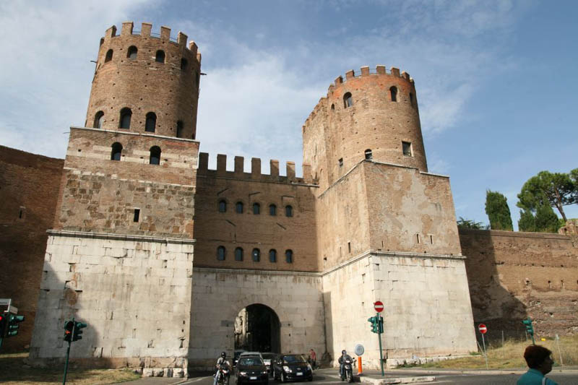
Economically, the trade system which had flourished during the Pax Romana broke down, as merchants could no longer safely travel the Mediterranean or the vast Roman road system. In an effort to create more money to pay the army, the emperors debased the coinage (meaning they put less and less precious metals like gold and silver into each coin), causing massive inflation, which further wrecked an already struggling economy. Trade and manufacturing became more localized, as wealthy Romans were unable to purchase products previously obtained from across the empire. Furthermore, in response to the debased currency, a barter system grew, foreshadowing the low-level economics of the Dark Ages. Plague killed hundreds of thousands as it knifed through hundreds of towns and cities, damaging the economy even further. The Pax Romana was dead.
There were several invasions of Germanic tribes, notably the Goths and Vandals, who succeeded at points in seizing portions of the empire and destroying both commerce and imperial cities. A series of military-minded emperors finally succeeded in defeating these invaders and stabilized the situation. Amongst them was Diocletian, who divided the empire into eastern and western halves and founded the Tetrarchy system, deciding the empire was too large for one man to govern. The empire had largely recovered from the crisis of the 3rd century, but the various problems it had suffered would appear again in the next century.

Barbarian Invasions

The barbarian invasions are the most concrete factor in Rome's fall. Beginning in the late 4th century CE, wave after wave of invaders crashed against the Roman empire and by 476 CE, the western half of the empire had fallen to these same barbarian tribes Romans had always looked at with disgust and contempt.
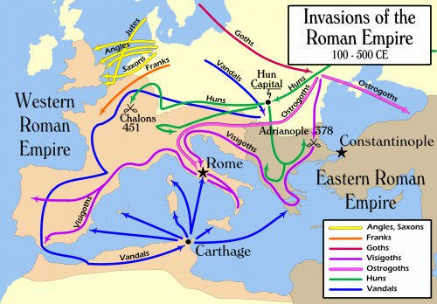
The storm began in 376 CE, when starving Gothic tribes came to the Danube river near Constantinople asking for aid from Rome. The emperor Valens agreed to give the Goths food and supplies in exchange for service in the Roman army; he quickly went back on his promise and never delivered any aid to the starving Goths and their families. Eventually, the Goths revolted and Valens was killed at the Battle of Adrianople in 378 CE. Subsequently, the Goths made a permanent home in the Roman empire, migrating from Greece to Italy eventually, sacking the city of Rome in 410 CE. In 406 CE, a combined force of Vandals, Alans, and Suevi barbarians crossed the frozen Rhine river into Roman Gaul and began an invasion that would last decades, slowly taking province after province from the Romans. Saxon and Angles from Scandinavia began migrating to Roman Britain, while the Franks slowly gained control of much of what would become modern-day France.
The culprits behind these many invasions were the Huns. The Huns were a nomadic people from the Asian steppes (plains), a precursor to the later Mongols. Their leader, Attila the Hun, (whom the Romans called the "Scourge of God") drove these barbarian tribes from their ancestral homelands and into Roman territory while establishing their own tributary empire. The Huns themselves invaded Roman territory not long after, but after a long campaign of destruction a combined Roman-Gothic army defeated the Huns at the Battle of Chalôns (451 CE). Attila's empire did not long survive his own death in 4... CE and quickly collapsed under the reign of his sons.
But the Romans were also to blame for these invasions. Ironically, having been in contact with Romans and their wealth for centuries, many of these barbarian tribes had become organized and hierarchal enough to march thousands of their own people under one or two leaders in coordinated efforts to seize territory and supplies, while remaining a cohesive unit. Three hundred years earlier, this was an unlikely occurrence; now it was the norm. The Romans were able to fight off the numerous invasions and prevent total collapse in the Western Empire for nearly a century, but in 476 CE, the last Roman emperor was deposed by the Gothic king Theoderic who claimed Italy as his own kingdom.

Mercenaries and Traitors

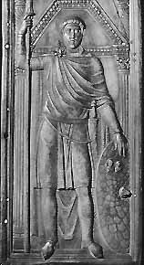
Rome had always used barbarian soldiers to supplement their armies. They were called auxiliaries and were usually specialized in warfare the Romans themselves were not skilled in, such as cavalry (horsemen) or archer units. By the 4th century CE however, the Romans were incorporating entire groups of barbarians as mercenaries (called Foederati) within their armies to add numbers to the Roman army. Typically, these barbarian warriors served under their own leaders and were considered disposable by Roman generals. Over time, barbarian leaders gradually became part of the Roman army hierarchy and eventually the Roman government. The half-barbarian general Stilicho practically ruled the Western half of the empire for the emperor Honorius, and was an able and effective administrator and general (see picture at right).
The advantages of using barbarian troops were many. The barbarians already had their own leaders, training, and weapons, so Rome paid very little in comparison with recruiting and outfitting their own soldiers. At a time of serious inflation and monetary problems throughout the empire, the cheap cost of these troops was an undeniable advantage, while providing much needed manpower. Plague swept through many Roman cities during the 3rd and 4th centuries, depleting the number of soldiers the Roman empire could recruit. Furthermore, buying off certain barbarian tribes and using them to fight one another helped to keep the numerous invading groups divided and in conflict.
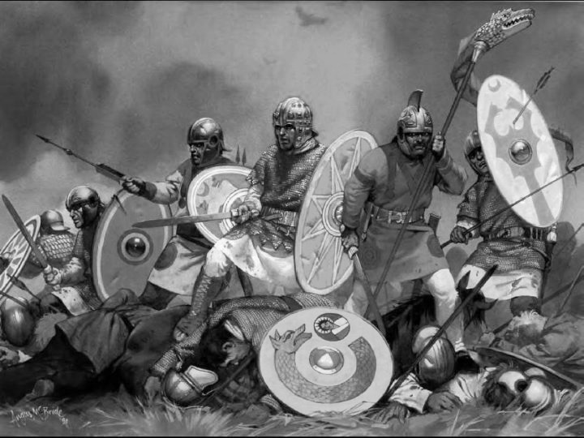
The reliance on these barbarian soldiers ultimately proved fatal to the empire. Barbarian troops were less likely to die for an abstract idea like "Roman pride," much less an empire that clearly did not want them. Certain tribes like the Goths settled within the empire and migrated, causing significant damage, even as the Romans tried to bribe them to serve in the Roman army. This became standard and other tribes like the Franks were given land in exchange for service in the Roman military. Later, these lands would break off from the empire and become the independent kingdoms of medieval Europe. Eventually, "true" Roman soldiers and barbarian soldiers were nearly indistinguishable, as more and more barbarian were recruited to serve in a dwindling Roman army. The loyalty of these soldiers proved to be doubtful at best. The Gothic king Theoderic, who deposed the last Roman emperor in the western half of the Empire in 476 CE, was raised in Constantinople, spoke Latin and Greek, and even held office in the Roman government.

Christianity

One of the more controversial causes of Rome's fall is the influence of Christianity upon the empire. While estimates widely vary, Christianity had grown from a strange, persecuted splinter sect of Judaism to a minority religion of the Roman empire by the 4th century CE (roughly 10% of Romans were Christian by 300 CE). The 18th century historian Edward Gibbon, whose book The Decline and Fall of the Roman Empire first posited the theory that Christianity made the empire weaker, stating:

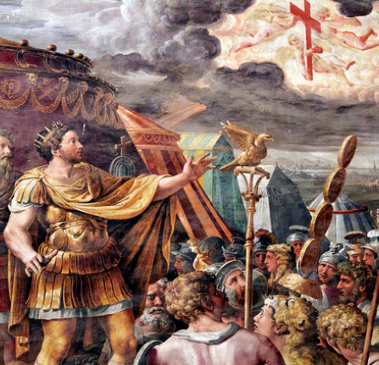
"... Christianity had some influence on the decline and fall of the Roman empire. The clergy successfully preached the doctrines of patience... the active virtues of society were discouraged; and the last remains of military spirit were buried in the cloister [monastery]: a large portion of public and private wealth was consecrated to the false demands of charity and devotion; and the soldiers' pay was lavished [instead] on the useless multitudes of both sexes who could only plead the merits of abstinence and chastity. Faith... kindled the flame of theological discord; the church, and even the state, were distracted by religious factions, whose conflicts were sometimes bloody and always implacable; the attention of the emperors was diverted from camps to synods [church councils]; the Roman world was oppressed by a new species of tyranny... The sacred indolence [laziness] of the monks was devoutly embraced by a servile and effeminate age; but if superstition had not afforded a decent retreat, the same vices would have tempted the unworthy Romans to desert, from baser motives, the standard of the republic..."

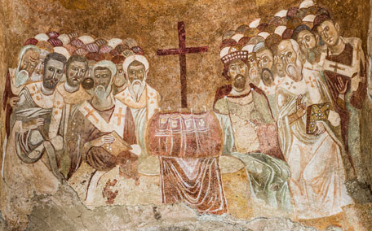
Although Gibbon's judgment of Christianity is likely tied to his own poor experiences with religion, his criticism is not entirely inaccurate. After the emperor Constantine's conversion in 312 CE, early Christianity was plagued by conflict over church doctrine and teachings (whether to use leavened or unleavened bread during mass, the nature of Jesus, the hierarchy of the church, etc.) and Roman officials and bishops devoted much time and energy to solving them, while also repressing any teaching considered "heretical". There are records of major rioting in cities over church teachings and the execution of heretics. This disrtaction at a time when barbarians were sometimes literally at the gates did not help preserve the empire. The emperor Julian even tried to bring back paganism as the dominant religion in the 360's CE, but was killed in battle with the Persians before he could roll back the tide of the Christian advance.
When the city of Rome was plundered in 410 CE, many pagans blamed the rising Christian religion, which was practiced by more than half the population by the 5th century CE. By this time, paganism was well in decline, as many temples had been closed or destroyed and Christianity had become the official religion of the Roman empire, for better or for worse.

Economic Decline

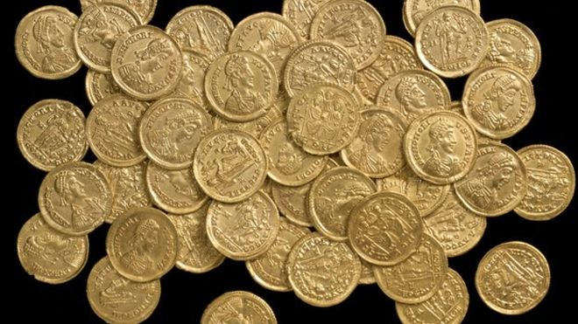
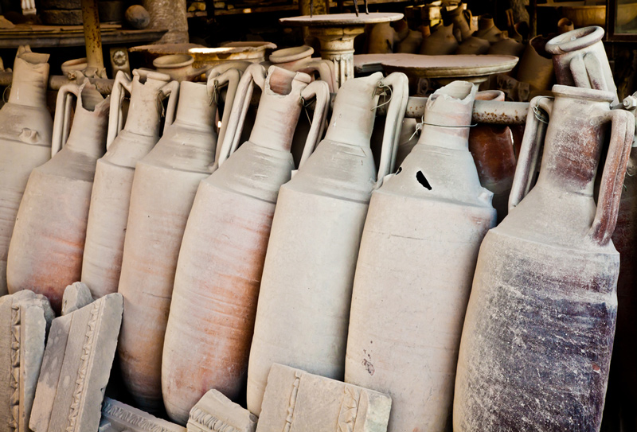
Even as Rome was under attack from outside forces, it was also crumbling from within thanks to a severe financial crisis. Constant wars and overspending had significantly lightened imperial resources, and taxation and inflation had widened the gap between rich and poor. In the hope of avoiding the taxman, many members of the wealthy classes had even fled to the countryside and set up independent states. At the same time, the empire was rocked by a labor deficit. Rome’s economy depended on slaves to till its fields and work as craftsmen, and its military might had traditionally provided a fresh influx of conquered peoples to put to work. But when expansion ground to a halt in the second century, Rome’s supply of slaves and other war treasures began to dry up. A further blow came in the fifth century, when the Vandals claimed North Africa, destroying the flow of grain and taxes from a critical Roman province, and began disrupting the empire’s trade by prowling the Mediterranean as pirates. With its economy faltering and its commercial and agricultural production in decline, the Empire began to lose its grip on Europe.
In the extreme example of Roman Britain (see map left), the economic decline began by 370 CE. Mass production, local commerce, heavy coin use, and urban populations all began dwindling to a considerable degree. Pottery mass production dropped to nearly zero within a single generation, while iron working ceased by 400 CE, to the point that people stopped using nails and other everyday iron implements. Most cities were virtually abandoned by the early 5th century, with walls crumbling, streets filled with garbage, and sewers overflowing. In one extreme instance, archaeologists found a funeral urn that had been dumped out and used to collect water, as new pottery was non-existent. Roman Britain was unrecognizable from the thriving province it had been 100 years earlier. While other Roman provinces did not suffer the incredible collapse of Roman Britain, the end of economic prosperity across much of the empire meant Roman soldiers could not be paid, which then left the military without the numbers needed to stop barbarian invaders from gobbling up more and more Roman territory, which in turn meant less tax revenue going to Rome and continued the vicious cycle.

Rise of the Eastern Empire

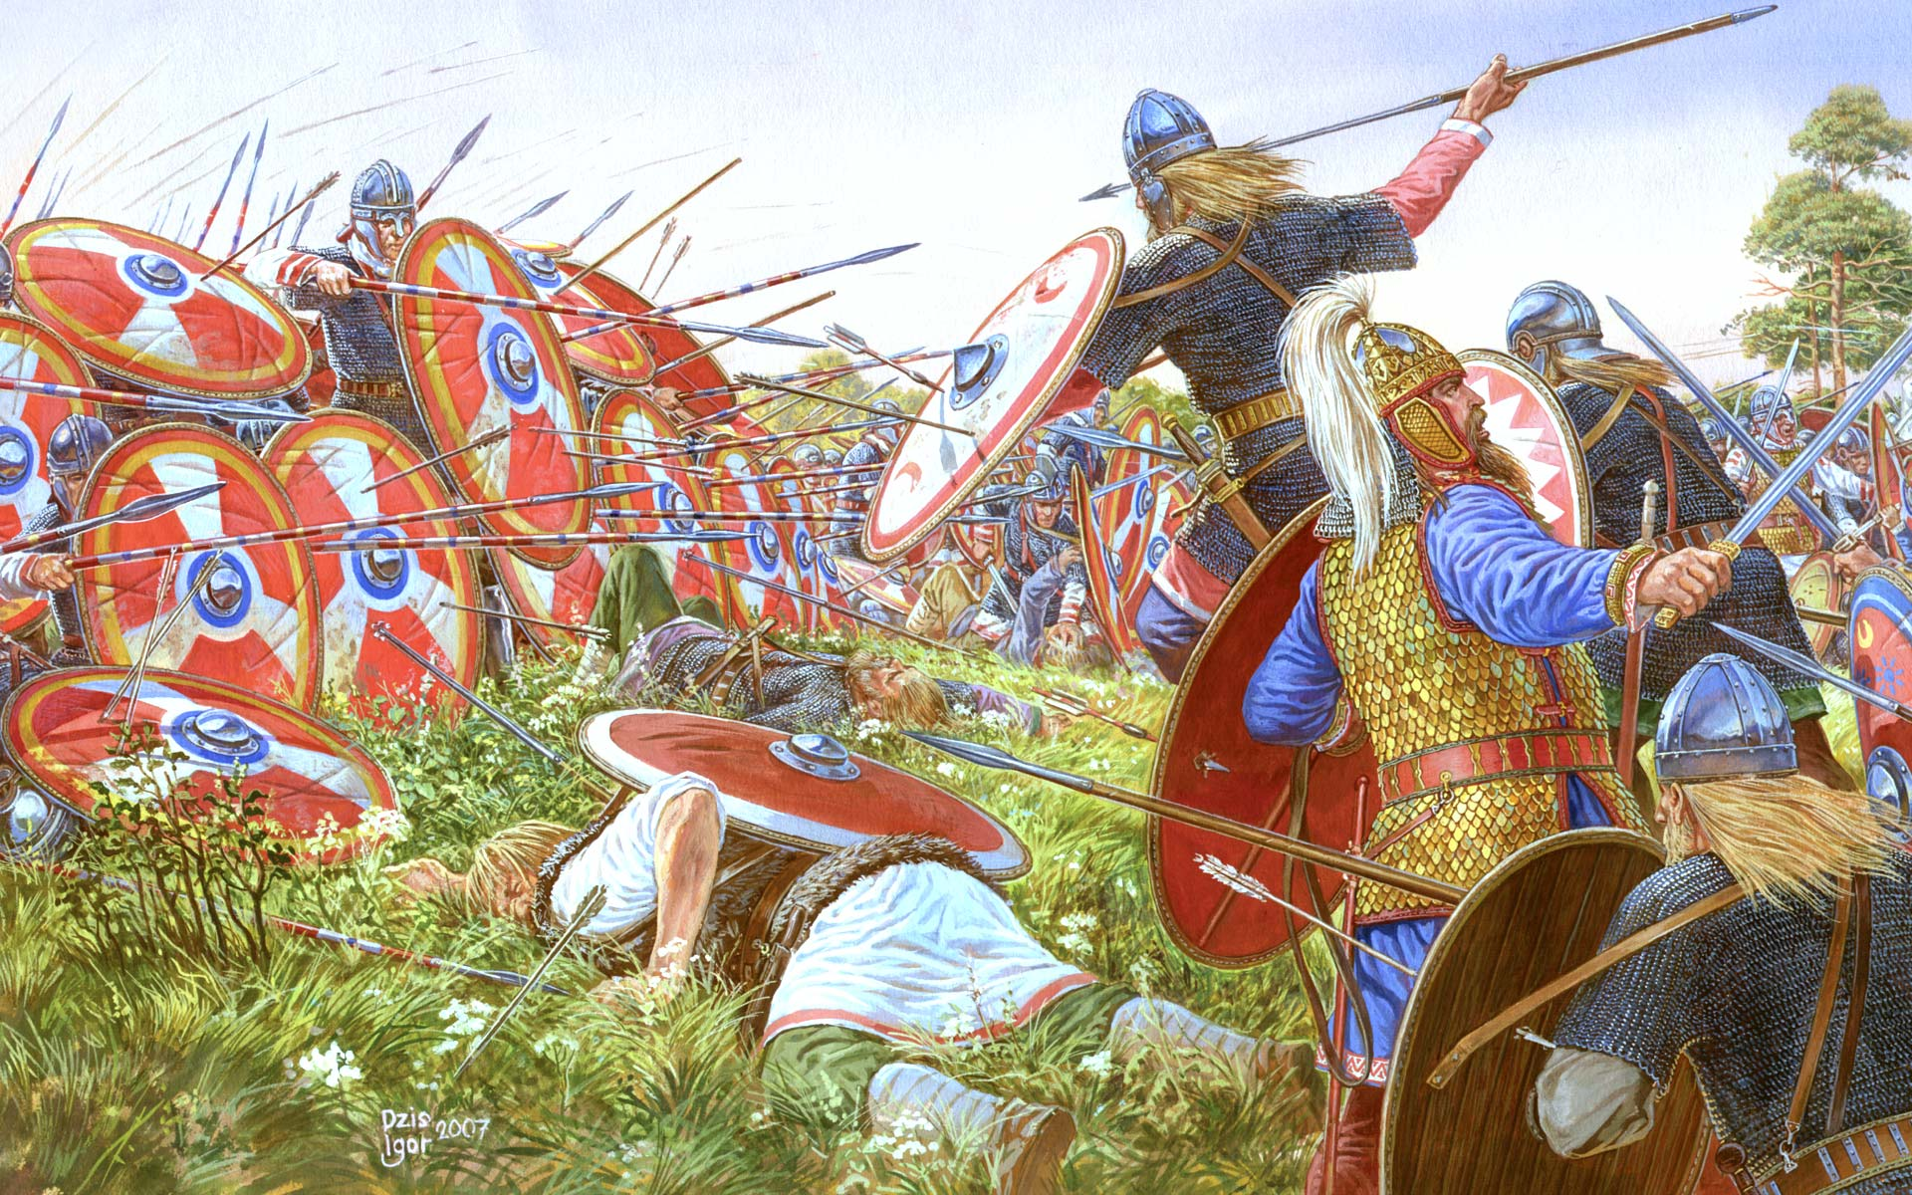
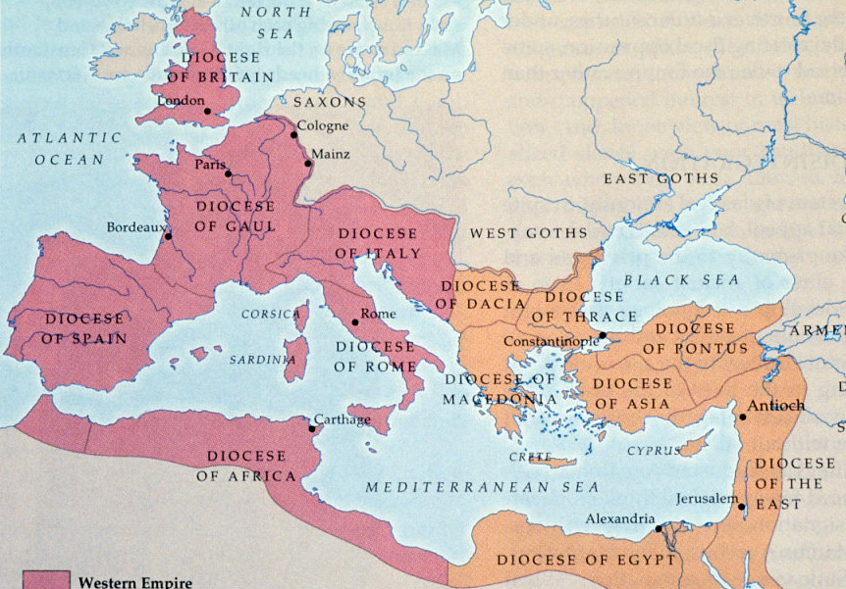
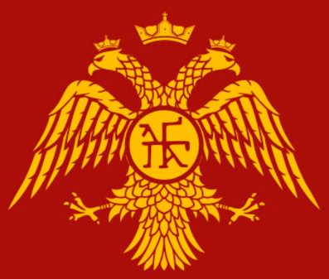
The fate of Western Rome was partially sealed in the late third century, when the Emperor Diocletian divided the Empire into two halves—the Western Empire seated in the city of Milan, and the Eastern Empire in Byzantium (see map below). The division (made permanent in 395 CE) made the empire more easily governable in the short term, but over time the two halves drifted apart. East and West failed to adequately work together to combat outside threats, and the two often squabbled over resources and military aid. Notably, at the Battle of Adrianople in 378 CE (see right), the Eastern emperor Valens attacked a barbarian tribe without waiting for his Western counterpart, because he feared he would have to share the glory and spoils after a victory; Valens would be defeated and killed in the battle, sending the empire into a leadership crisis. The defeat opened the empire to this barbarian tribe, known as the Goths, who would then play a critical role in the destruction of the Western Roman Empire (see passage on barbarian invasions). As the gulf widened, the largely Greek-speaking Eastern Empire grew in wealth while the Latin-speaking West descended into economic crisis with a declining urban population. Most importantly, the strength of the Eastern Empire served to divert Barbarian invasions to the West; Attila the Hun (a barbarian invader of the 5th century CE) would try his luck in the weaker, Western part of the empire after failing to take any major cities in the East.
After the Emperor Constantine founded the city of Constantinople (originally called "New Rome") on the former site of Byzantium, the shift from West to East had truly begun. Constantinople was lavished with treasures from all corners of the empire, including monuments taken from Rome itself. The city would become the largest in all of Europe, the jewel of the Eastern Empire at the crossroads of Europe and Asia. Italy and the city of Rome—which only had symbolic value for many in the East—were left vulnerable. Eastern Roman emperors also had their own difficulties dealing with the powerful Sassanid Persian empire, and naturally devoted most of their resources to their own defense. The Western political structure would finally disintegrate in the fifth century with a stream of weak emperors and barbarian advisors, but the Eastern Empire endured in some form for another thousand years before being overwhelmed by the Ottoman Empire in the 1400s. This fact begs the question, did the Roman empire actually fall in 476 CE?

