SELECTION FROM THE ZHUANGZI: CHAPTER 3, “THE SECRET OF CARING FOR LIFE”
Introduction
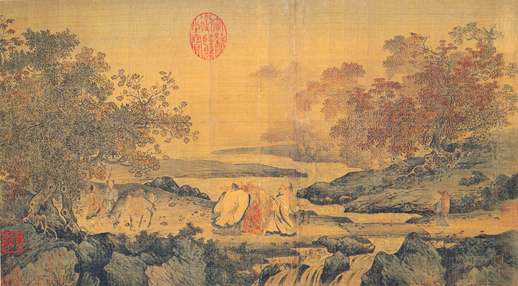
Zhuangzi (also called Zhuang Zhou) was an historical figure who lived somewhere around 360-280 BCE. The long book that bears his name is a combination of material that represents his own thinking and of other writings incorporated by various compilers and editors. Like Confucius, Mencius, Han Fei and others, Zhuangzi lived during the time when the kings of the Zhou dynasty had little real power and the kingdom had disintegrated into feudal states that were constantly at war with each other in shifting patterns of alliances and enmities [hatred]. During the Warring States period (480-221 BCE), Zhuangzi and Laozi were not considered to be part of a single school of thought. Zhuangzi is more concerned with escaping from the world; Laozi, with cunning ways of ruling it. During the Han dynasty, both works’ concern with the Dao (the “Way” of Heaven) and their mystical understanding of that term inspired historians to lump them together under the single category of “Daoism.” The name stuck. Zhuangzi and Laozi are now forever linked as the two great progenitors of Daoist philosophy and religion.
Selected Document Excerpt with Questions
Selection from the Zhuangzi: Chapter 3, “The Secret of Caring for Life” Your life has a limit but knowledge has none. If you use what is limited to pursue what has no limit, you will be in danger. If you understand this and still strive for knowledge, you will be in danger for certain! If you do good, stay away from fame. If you do evil, stay away from punishments. Follow the middle; go by what is constant, and you can stay in one piece, keep yourself alive, look after your parents, and live out your years.
1) How does Zhuangzi suggest that one live one’s life? How might his recommendation have been influenced by the chaotic and warlike times in which he lived?

[Story of Daoism]: Cook Ding was cutting up an ox for Lord Wenhui. At every touch of his hand, every heave of his shoulder, every move of his feet, every thrust of his knee! He slithered the knife along with a zing, and all was in perfect rhythm, as though he were performing the dance of the Mulberry Grove or keeping time to the Jingshou music.1
“Ah, this is marvelous!” said Lord Wenhui. “Imagine skill reaching such heights!”
Cook Ding laid down his knife and replied, “What I care about is the Way, which goes beyond skill. When I first began cutting up oxen, all I could see was the ox itself. After three years I no longer saw the whole ox. And now ‐‐ now I go at it by spirit and don’t look with my eyes. Perception and understanding have come to a stop and spirit moves where it wants. I go along with the natural makeup, strike in the big hollows, guide the knife through the big openings, and follow things as they are. So I never touch the smallest ligament or tendon, much less a main joint.
2) How is the concept of “the Way” (Dao) relevant to understanding the story of Cook Ding?

3) How does Zhuangzi’s approach to life contrast to that of Confucius and Mencius (Confucianism)? To that of Han Fei and Lord Shang (Legalism)?

From Sources of Chinese Tradition, compiled by Wm. Theodore de Bary and Irene Bloom, 2nd ed., vol. 1 (New York: Columbia University Press, 1999), 103-104. © 1999 Columbia University Press. Reproduced with the permission of the publisher. All rights reserved.

