Cyrus the Great: The Decree of Return for the Jews, 539 BCE

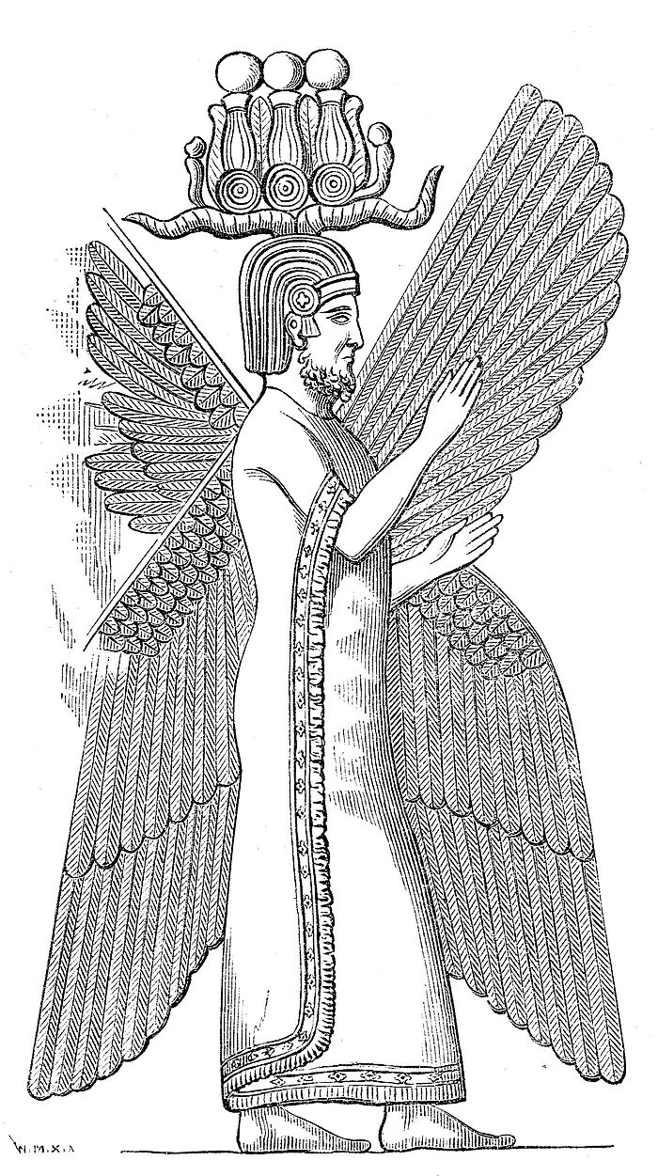
From The Kurash Prism:
I am Kurash [ "Cyrus" ], King of the World, Great King, Legitimate King, King of Babilani, King of Kiengir and Akkade, King of the four rims of the earth, Son of Kanbujiya, Great King, King of Hakhamanish, Grandson of Kurash, Great king, King of Hakhamanish, descendant of Chishpish, Great king, King of Hakhamanish, of a family which always exercised kingship; whose rule Bel and Nebo [two Perisan gods] love, whom they want as king to please their hearts. When I entered Babilani as a friend and when I established the seat of the government in the palace of the ruler under jubilation and rejoicing, Marduk, the great lord, induced the magnanimous inhabitants of Babilani to love me, and I was daily endeavoring to worship him.... As to the region from as far as Assura and Susa, Akkade, Eshnunna, the towns Zamban, Me-turnu, Der as well as the region of the Gutians, I returned to these sacred cities on the other side of the Tigris the sanctuaries of which have been ruins for a long time, the images which used to live therein and established for them permanent sanctuaries. I also gathered all their former inhabitants and returned them to their habitations. Furthermore, I resettled upon the command of Marduk, the great lord, all the gods of Kiengir and Akkade whom Nabonidus had brought into Babilani to the anger of the lord of the gods, unharmed, in their former temples, the places which make them happy.

From The Hebrew Bible, Ezra 1:1-8:
In the first year of Cyrus, king of Persia, in order to fulfill the word of the Lord spoken by Jeremiah, the Lord inspired King Cyrus of Persia to issue this proclamation throughout his kingdom, both by word of mouth and in writing: "Thus says Cyrus, king of Persia: "All the kingdoms of the earth the Lord, the God of heaven, has given to me, and he has also charged me to build him a house in Jerusalem, which is in Judah. Whoever, therefore, among you belongs to any part of his people, let him go up, and may his God be with him! Let everyone who has survived, in whatever place he may have dwelt, be assisted by the people of that place with silver, gold, and goods, together with free will offerings for the house of God in Jerusalem.' Then the family heads of Judah and Benjamin and the priests and Levites---everyone, that is, whom God had inspired to do so---prepared to go up to build the house of the Lord in Jerusalem. All their neighbors gave them help in every way, with silver, gold, goods, and cattle, and with many precious gifts besides all their free-will offerings. King Cyrus, too, had the utensils of the house of the Lord brought forth which Nebuchadnezzar had taken away from Jerusalem and placed in the house of his god. Cyrus, king of Persia, had them brought forth by the treasurer Mithredath, and counted out to Sheshbazzar, the prince of Judah.
Source: From: Charles F. Horne, ed., The Sacred Books and Early Literature of the East, (New York: Parke, Austin, & Lipscomb, 1917), Vol. I: Babylonia and Assyria, pp. 460-462; The Bible (Douai-Rheims Version), (Baltimore: John Murphy Co., 1914).

QUESTIONS

1) Compare the two accounts of Cyrus' decree. What could explain these differences?

2) How does the Jewish account of the decree portray Cyrus?

3) Why might this policy of tolerance be advantageous to Cyrus and his successors? What problems might it cause?

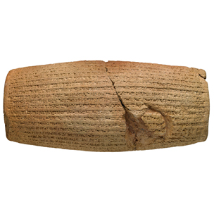
Cylinder of Cyrus Text-Found on a stone cylinder in Mesopotamia, documenting Cyrus' deeds
The Prince of Peace
[23] I took up my home in the royal palace amidst rejoicing and happiness. Marduk [a god], the great lord, /established as his fate (šimtu)\ for me a generous heart of one who loves Babylon, and I daily attended to his worship.
[24] My vast army marched into Babylon in peace; I did not permit anyone to frighten the people of [Sumer] /and\ Akkad.
[25] I sought the welfare of the city of Babylon and all its sacred centers. As for the citizens of Babylon, upon whom he [the previous king] imposed a corvée [slavery] which was not the gods' wish and not befitting them,
[26] I relieved their weariness and freed them from their service. Marduk, the great lord, rejoiced over [my good] deeds.

Religious Measures
[28] and in peace, before him, we mov[ed] around in friendship. [By his] exalted [word], all the kings who sit upon thrones
[29] throughout the world, from the Upper Sea to the Lower Sea, who live in the dis[tricts far-off], the kings of the West, who dwell in tents, all of them,
[30] brought their heavy tribute before me and in Babylon they kissed my feet. From [Babylon] to Aššur and (from) Susa, Agade, Ešnunna, Zamban, Me-Turnu, Der, as far as the region of Gutium, the sacred centers on the other side of the Tigris, whose temples had been abandoned for a long time,
[32] I returned the images of the gods, who had resided there,^{note}[Ii.e., in Babylon.] to their places and I let them dwell in eternal abodes. I gathered all their inhabitants and returned to them their dwellings.
[33] In addition, at the command of Marduk, the great lord, I settled in their habitations, in pleasing abodes, the gods of Sumer and Akkad, whom Nabonidus, to the anger of the lord of the gods, had brought into Babylon.

QUESTIONS
1) What does Cyrus first do when he enters Babylon?

2) What is tribute? Who is coming to Cyrus' feet?

3) How does Cyrus show tolerance for other religions and their followers?

