Conversion of Russia
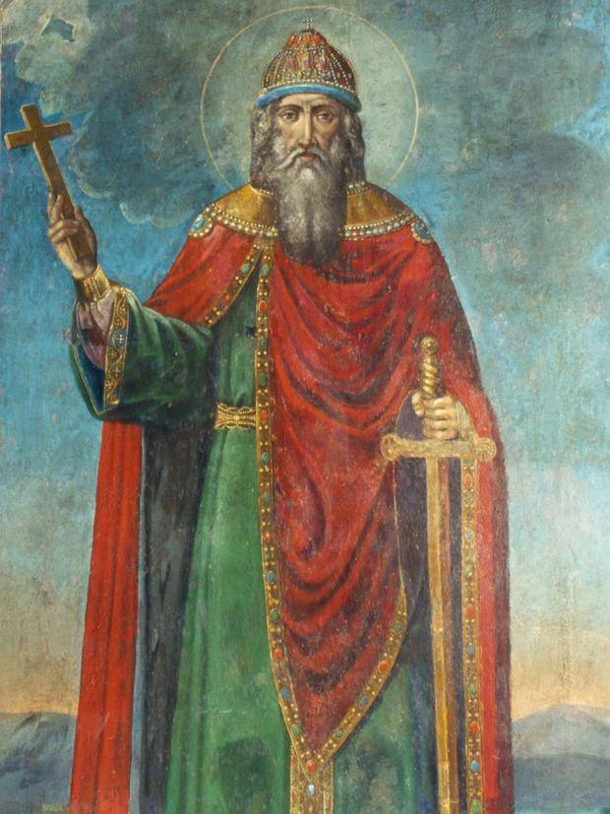
Vladimir then announced the return of the diplomats who had been sent out, and suggested that their report be heard. He thus commanded them to speak out before his vassals. The envoys reported: "When we journeyed among the Bulgars, we saw how they worship in their temple, called a mosque… Their religion is not fitting for us. Then we went among the Germans, and saw them performing many ceremonies in their temples; but we beheld no glory there. Then we went on to Greece [specifically Constantinople], and the Greeks led us to the structures where they worship their God, and we knew not whether we were in heaven or on earth. For on earth there is no such splendor or such beauty, and we are at a loss how to describe it. We know only that God dwells there among men, and their service is fairer than the ceremonies of other nations. For we cannot forget that beauty. Every man, after tasting something sweet, is afterward unwilling to accept that which is bitter, and therefore we cannot dwell longer here." Vladimir then inquired where they should all accept baptism, and they replied that the decision rested with him
By divine agency, Vladimir was suffering at that moment from a disease of the eyes, and could see nothing, being in great distress... Upon experiencing this miraculous cure [he was cured by a baptism allegedly], Vladimir glorified God, saying, "I have now perceived the one true God." When his followers beheld this miracle, many of them were also baptized…
When the prince arrived at his capital, he directed that the idols should be overthrown and that some should be cut to pieces and others burned with fire... he ordained that churches should be built and established where pagan idols had previously stood.

QUESTIONS:
- What convinces Vladmir to adopt the Christian religion, specifically that of the Greeks?

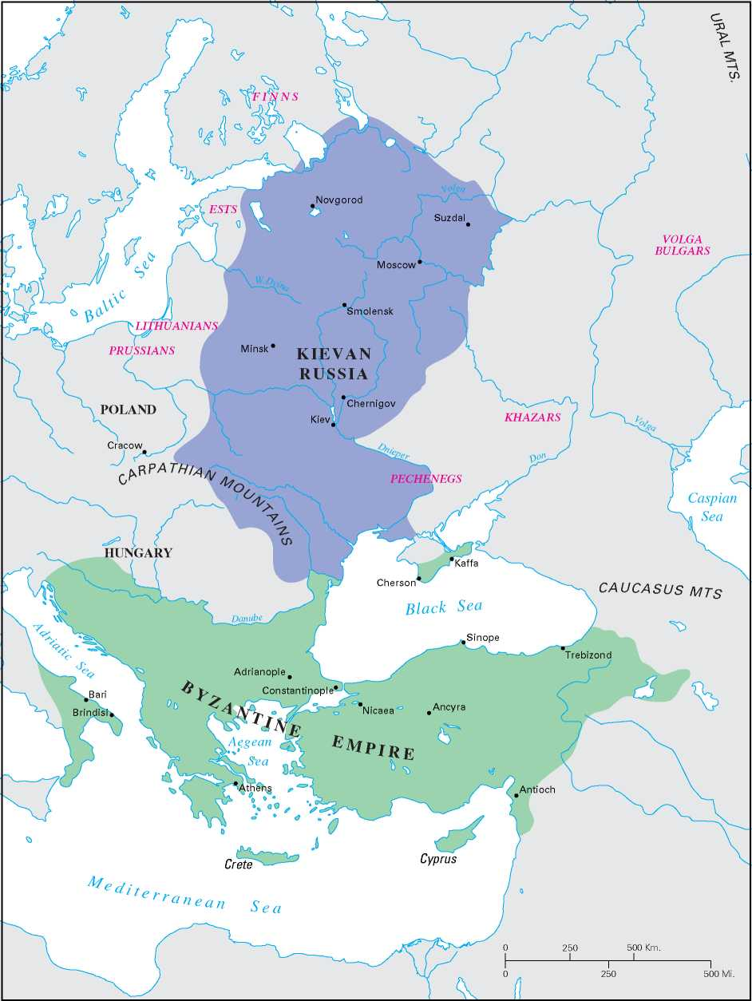
- What structure do you think the diplomats of Vladmir may have seen in Constantinople that convinced them of the Greek religion’s superiority? Why does it convince them?

- What other leader we have recently spoken about destroyed pagan idols (polytheistic idols) after “converting” to a new religion? Why are idols forbidden in both religions?

