Constantine Founds [builds] Constantinople, 324 CE

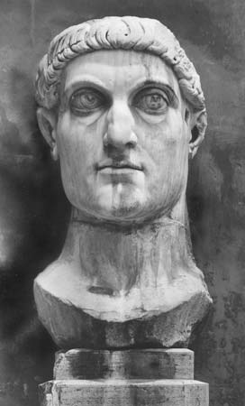
[Davis Introduction] Sozomen (d. c. 450 CE):
Note that Constantinople was from the outset a Christian city; as contrasted with old Rome, where paganism still kept a firm grip, at least on much of the population, for nearly a century.
Sozomen (d. c. 450 CE), Ecclesiastical History, II.3:
The Emperor [Constantine] always intent on the advancement of religion built splendid Christian temples to God in every place---especially in great cities such as Nicomedia in Bithynia, Antioch on the Orontes, and Byzantium. He greatly improved this latter city [Constantinople], and made it equal to Rome in power and influence; for when he had settled his empire as he was minded, and had freed himself from foreign foes, he decided on founding a city which should be called by his own name, and should equal in fame even Rome...
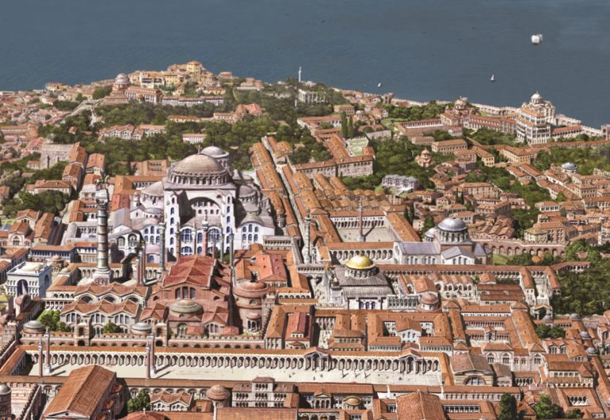
Led by the divine hand [God], he came to Byzantium... and here he desired to build his city, and render it worthy of the name of Constantine. In obedience to the command of God, he therefore enlarged the city formerly called Byzantium, and surrounded it with high walls; likewise he built splendid dwelling houses; and being aware that the former population was not enough for so great a city, he peopled it with [brought in] men of rank [nobles] and their families, whom he summoned from Rome... He imposed special taxes to cover the expenses of building and adorning the city, and of supplying the inhabitants with food. He erected all the needed edifices for a great capital---a hippodrome [race track], fountains, porticoes and other beautiful adornments. He named it Constantinople and New Rome---and established it as the Roman capital for all the inhabitants of [Roman empire]
He created another Senate which he endowed with the same honors and privileges as that of Rome, and he strove to render the city of his name equal in every way to Rome in Italy; nor were his wishes in vain, for by the favor of God, it became the most populous and wealthy of cities. As this city became the capital of the Empire during the period of religious prosperity, it was not polluted by altars, Grecian temples, nor pagan sacrifices. Constantine also honored this new city of Christ by adorning it with many and splendid houses of prayer, in which the Deity vouchsafed to bless the efforts of the Emperor by giving sensible manifestations of his presence.

QUESTIONS
1) What examples of monumental architecture did Constantine build in his new capital? Why is it important for a capital to have such structures?

2) Why did Constantine move his capital away from Rome? How did he try to spread Christianity in his new city?

3) Why would Constantine want to make his new capital as similar as possible to Rome?

