Conquest of the Philippines

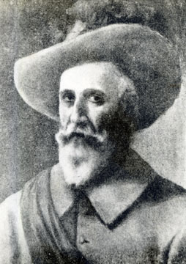
Spanish forces approached the Philippines in 1565 under the command of Miguel Lopez de Legazpi, who named the islands after King Phillip II of Spain. Legazpi over came local authorizes in Cebu and Manila in almost bloodless contests. Because the Philippines had no central government, there was no organized resistance to the intrusion. Spanish forces faced a series of small, disunited chiefdoms, most of which soon fell before Spanish ships and guns. By 1575 Spanish forces controlled the coastal regions of the central and northern islands and during the 17th century they extended their authority to most parts of the archipelago.

Spanish policy in the Philippines revolved around trade and Christianity. Manila soon emerged as a bustling multicultural port city- an entrepôt [center] for trade particularly in silk. Chinese merchants were especially prominent in Manila. They occupied a specially designated commercial district of the city. They supplied the silk goods that Spanish traders shipped to Mexico in the so-called “Manila galleons”. Their commercial success brought suspicion on their community, and resentful Spanish and Filipino residents massacred Chinese merchants by the thousands in at least six major eruptions of violence up until 1819. Nevertheless, Spanish authorities continued to rely heavily on the wealth that the Chinese merchants did bring.

Apart from promoting trade, Spanish authorizes in the Philippines also sought to spread Roman Catholicism throughout the archipelago. Spanish rulers and missionaries pressured prominent Filipinos to convert to Christianity in hopes of persuading others to follow their example. They opened schools to teach the fundamentals of the Christian doctrine, along with the basic literacy in densely populated areas throughout the island. Filipinos turned increasingly to Christianity and by the 19th century, the Philippines had become one of the most fervent [passionate] Roman Catholic lands in the world.
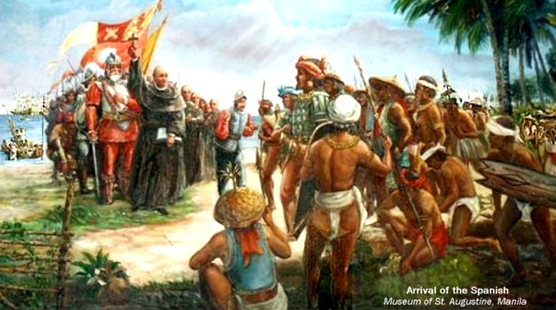

Conquest of Java
Dutch Mariners, who imposed their rule on the island of Indonesia, did not worry about seeking converts to Christianity, but concentrated instead on the trade in spices, especially cloves, nutmeg and mace. The architect of the Dutch policy was Jan Pieterszoon Coen, who in 1619 founded Batavia on the island of Java to serve as an entrepôt [trade center] for the VOC. Batavia occupied a strategic site near the Sunda Strait and its market attacked both Chinese and Malay vessels. Coen’s plan was to establish a VOC monopoly over spice production and trade, thus enabling Dutch merchants to reap enormous profits in European markets. Coen brought his naval power to bear on the small Indonesia islands and forced them to deliver spices only to VOC merchants. On the larger islands such as Java, he took advantage of tensions between local princes and authorized and traded concessions from many in return for providing them with aid against the others. By the late 17th century, the VOC controlled all the ports in Java as well as most of the important spice bearing islands throughout the archipelago.

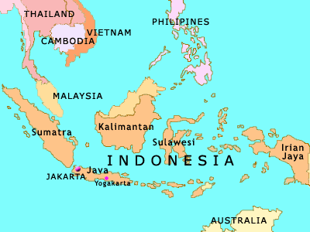
Dutch numbers were too few for them to rule directly over their whole Southeast Asia Empire. They made alliances with local authorities to maintain order in most regions, reserving for direct Dutch rule only Batavia and the most important spice-bearing islands such as the clove producing Amboina and the Banda Islands. The Dutch did not embark on plans for conquest for purposes of adding to their holdings, but they uprooted spice-bearing plans on islands they did not control and mercilessly attacked peoples who sold their spices to merchants not associated with the VOC. Monopoly profits from the spice trade not only enriched the VOC but made the Netherlands the most prosperous land in Europe throughout most of the 17th Century.

