Congress of Vienna Game
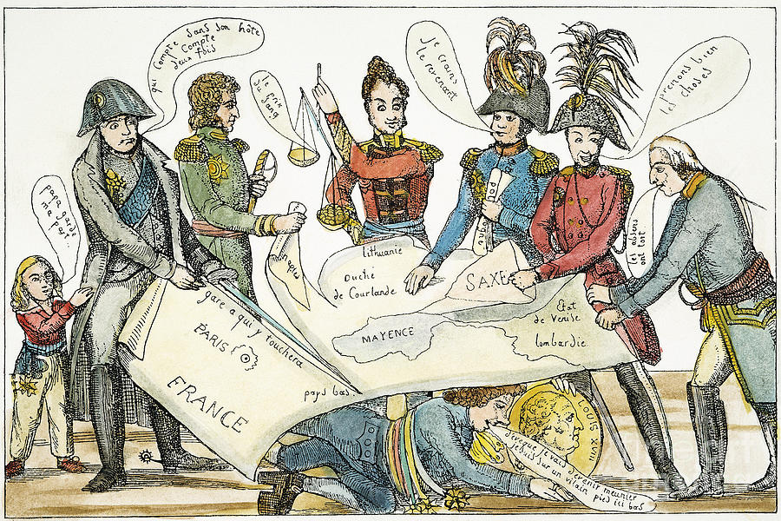
Directions: After Napoleon and Revolutionary France was finally defeated (1814 and then again in 1815), the victorious nations of Europe met at the Congress of Vienna to 1) redraw the map of Europe and 2) provide a balance of power to prevent another colossal conflict like the Napoleonic Wars. Each of you will take the role of one of the five nations at this congress. These five nations wanted to provide stability for Europe but also had their own selfish goals; it is your job to balance these major goals in your negotiations with the other nations of Europe. For homework, you will read your profile on your nation and diplomat and then meet with your group the next day and discuss strategy. Whichever group achieves the most of their objectives will receive BONUS POINTS for an outline (maximum 15 pages). Good luck, remember to establish what goals you want to achieve, in addition to providing stability for Europe.

5 Nations: France-Tallyrand
Austria-Metternich
Prussia-King Frederick William III
Great Britain-Castlereagh
Russia-Czar Alexander I

Homework: Read profile of each diplomat and answer the worksheet.

As a group:

1) What are your nation's goals?

a. Best Case Scenario-Your "wishlist", what would be your ideal situation in which you get everything your nation wants? Write this wishlist of goals on an index card to announce to the class before we begin negotiations.

1.

2.

3.

4.

b. Acceptable Scenario: What is the bare minimum you must achieve?

1.
2.

2) Who are your enemies based off your profile?

Who are your potential allies? (Remember: The enemy of my enemy is my friend)

3) This is a list of things you can negotiate with other nations. If your group wants to form an alliance, make a treaty, take land etc. YOU MUST GET THIS IN WRITING. Use a piece of paper and have one representative (one person from your group) from your nation and one from the other sign it to prove the agreement:

a. Make an alliance: you can only make alliances with TWO other nations total, no more. This can help provide stability for Europe.

b. Trade treaties: these treaties will increase your nation's wealth, as well as that of the other nation. Can only make with TWO other nations. Think geographically who is the best trade partner.

c. Make France a monarchy again or keep it as a republic: 4 out of 5 nations must agree to this change-will this provide stability?

d. Make Germany a unified nation, under Prussian domination: 3 out of 5 nation must agree to this change-will this provide stability?

e. Make Italy a unified nation: 3 out of 5 nation must agree to this change-will this provide stability?

f. Land Grab: Saxony (yellow), Independent Poland (red), and colonies and parts of France (blue). These three pieces of land can be negotiated for: 3 out of 5 nations must agree to give the land to one nation. Will this provide stability?

Figure out a strategy of what you can do with this list to achieve as many of your objectives as possible, balancing your nation's goals with the stability of Europe.

How will you get what you want?

How will you protect yourself?

What are you willing to compromise?

4) The game itself: Before the actual game, each group will announce their wishlist of goals using the index card created earlier (each group will then know who they want to begin speaking with). After this, there will 3 rounds of 5 minutes each. During these rounds, you and your group members may walk around and negotiate with other groups, trying to achieve your objectives, cutting deals and compromising for your goals. You and your group must agree on an alliance, treaty, land, grab, etc. sign it with the other group and hand in the paper to the teacher. At the end of the round, there will be a 2-minute meeting with ONLY your group, no other nations can be spoken to. I will keep track of alliance and treaties on the board, changing the map when necessary. At the end of three rounds, I will collect your wishlists, see whose objectives were reached, were closest to their wishlist, which were not, and declare a winner.

We will compare our map of Europe to the actual map of Europe created at the Congress of Vienna and see how close we get during this game.

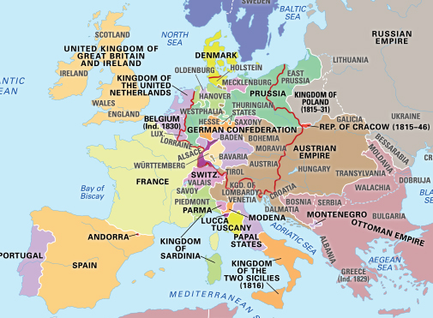
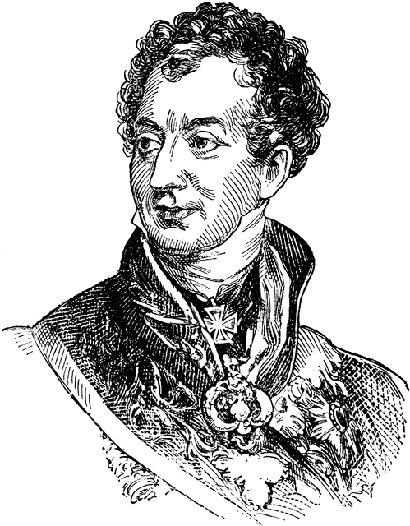
REMEMBER: THIS IS POLITICS. It is cutthroat, brutal, and there will be only ONE winner of the EXTRA CREDIT. Do anything within the rules to achieve your goals: lie, mislead, deceive, compromise, MAKE DEALS and WIN. Your major goal is the stability of Europe and preventing another conflict like the Napoleonic Wars. But you also want your nation to come away with some goals achieved. Good luck and make the ghost of Metternich proud!

