CONFUNCIANISM

The philosopher Confucius (or Kongzi, c. 551 to c. 479 BCE) is the recognized founder of Confucianism. Originally, Confucianism was composed of a set of political and moral doctrines with the teachings of Confucius as its basis.

THE APPROACH & TEACHINGS OF CONFUCIUS
While his neighbors in India were obsessed with metaphysical debates, Confucius was solely focused on everyday concerns. He was indifferent to the big mysteries of existence such as the origin or the universe, god or the afterlife. His famous answers to this type of question were:
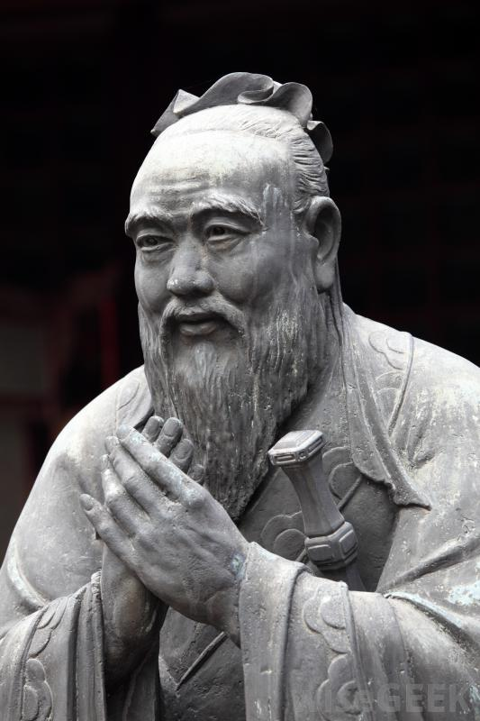
"We do not yet know how to serve man, how can we know about serving the spirits?
We don't know yet about life, how can we know about death?"

Confucianism revolves almost entirely around issues related to the family, morals, and the role of the good ruler. Confucius speaks of the five relationships: father-son, husband-wife, ruler-subject, older brother-younger brother friend to friend. It stresses the need for benevolent [compassionate] and frugal rulers, the importance of inner moral harmony and its direct connection with harmony in the physical world. Every person had his/her role in society and this strict hierarchy would keep society from breaking into chaos. Part of this hierarchy was the father-figure; the oldest male in each family had ultimate authority. Confucianism enforced patriarchal [male-controlled] values that minimized women's worth and kept women as second-class citizens, a problem that still exists in China today.

Rulers and teachers, according to this view, are important models for society: a good government should rule by virtue and moral example rather than by punishment or force. Filial piety [respect for elders] and ancestor worship, which are old traditional Chinese values, are also part of the key components of Confucian doctrine.

Confucius was against the idea that some men are born superior to others. During his time it was held that nobility was a quality determined by status and that belonging to a specific social circle made a person morally superior. Confucius challenged this idea by saying that being morally superior had nothing to do with the blood, rather, it was a matter of character and personal development through education, a revolutionary concept at that time.

THE ORIGINS OF CONFUCIANISM
To ignore the mysteries of life is the price Confucius had to pay to focus his energy on this world. Confucius thought that going back to the traditional ways was the only path for society to get back on track. He lived during a time when the Zhou dynasty was immersed in serious political conflicts [Warring States Period].

The attention of Confucius was attracted towards very practical considerations of this world rather than seeking consolation in otherworldly notions. He decided to seek a solution for the challenges of his time, a way to cure a society which, nearly everyone agreed, was sick.

CONFUCIANISM & THE STATE
The teachings of Confucius have come down to our days through his Analects, a collection of sayings, maxims and different stories, probably compiled by Confucius' students. It was during the Han dynasty (206 BCE-220 CE) when Confucianism became the dominant political ideology and the Analects became known by that name.
THE ANALECTS

The Analects is not written in systematic way but rather in a poetic way that sometimes can be interpreted in different ways. These are some examples of its passages where Confucius said:

Wealth and honor are what every man desires. But if they have been obtained in violation of moral principles, they must not be kept. Poverty and humble station are what every man dislikes. But if they can be avoided only in violation of moral principles, they must not be avoided. A superior man never abandons humanity even for the lapse of a single meal. In moments of haste, he acts according to it. In times of difficulty or confusion, he acts according to it. (Analects 4:5)

The superior man wants to be slow in word but diligent in action. (Analects 4:24)

I transmit but do not create. I believe in and the love of the ancients. I venture to compare myself to our old Peng. (Analects 7:1)

LEGACY
The humanistic turn in Chinese philosophy is due to the enormous influence of Confucianism and it is humanism that is the most outstanding feature of Chinese philosophy as a whole. During most of Chinese history, Confucianism was seen as the preserver of traditional Chinese values, the guardian of Chinese civilization as such.

Adapted from Ancient Encyclopedia

