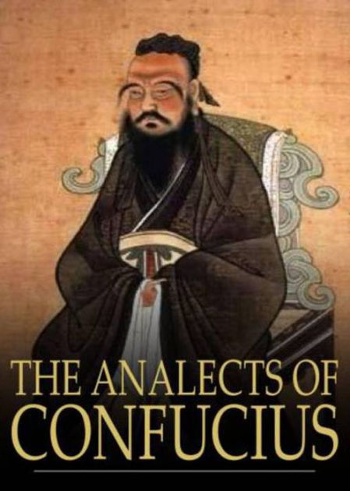
Document Excerpts with Questions (Longer selection follows this section) From Sources of Chinese Tradition, compiled by Wm. Theodore de Bary and Irene Bloom, 2nd ed., vol. 1 (New York: Columbia University Press, 1999), 45-50, 52, 54-55. © 1999 Columbia University Press. Reproduced with the permission of the publisher. All rights reserved.
General Selections from the Confucian Analects
1:2 Master You [You Ruo] said, “Among those who are loving toward their parents and friendly toward their brothers, those who want to offend their superiors are few indeed. Among those who are disinclined to offend against their superiors, there have never been any who are yet inclined to create disorder. The noble person concerns himself with the root; when the root is established, the Way is born. Being filial [loving] and fraternal [friendly] — is this not the root of humaneness?”
2:3 The Master [Confucius] replied, “Lead them by means of regulations and keep order among them through punishments, and the people will avoid them and will lack any sense of shame.1 Lead them through moral force (de) and keep order among them through rites (li), and they will have a sense of shame and will also correct themselves.”
4:5 The Master said, “Wealth and honor are what people desire, but one should not abide in them if it cannot be done in accordance with the Way. Poverty and lowliness are what people dislike, but one should not avoid them if it cannot be done in accordance with the Way. If the noble person rejects humaneness, how can he fulfill that name? The noble person does not abandon humaneness for so much as the space of a meal. Even when hard-pressed he is bound to it, bound to it even in time of danger.”
4:16 The Master said, “The noble person is concerned with rightness; the small person is concerned with profit.”

Questions:
1) What does Confucius mean by “filial piety?” How does the concept of filial piety give shape to the relations between parents and children and between rulers and subjects?

2) What assumptions does Confucius make about human nature when he says that one should lead the people through moral force rather than regulations and keep order among them through rites rather than punishments?

3) What is humaneness and why does Confucius consider it to be so important?

4) How would a government founded on Confucian principles compare to your own government?

5) Are Confucian principles relevant to the issues of practical life?

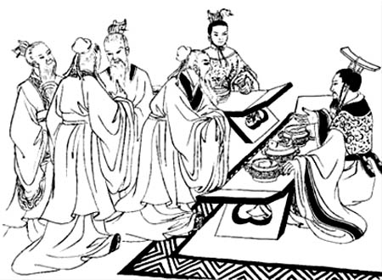
SELECTIONS FROM THE CONFUCIAN ANALECTS: ON GOVERNMENT
Introduction
Confucius (the Latinized version of Kong Fuzi, “master Kong”) or, to call him by his proper name, Kong Qiu (551-479 BCE) lived at a time of political turmoil and transition. Confucius and many of his contemporaries were concerned about the state of turmoil, competition, and warfare between the feudal states. They sought philosophical and practical solutions to the problems of government — solutions that, they hoped, would lead to a restoration of unity and stability. Confucius had no notable success as a government official, but he was renowned even in his own time as a teacher. His followers recorded his teachings a generation or two after his death, and these teachings remain influential in China, Vietnam, Korea, and Japan to this day. The anecdotes and records of short conversations compiled by his disciples go under the English title of the Analects. The excerpts from the Analects presented below are specifically concerned with the problem of government.
Document Excerpts with Questions (Longer selection follows this section) From Sources of Chinese Tradition, compiled by Wm. Theodore de Bary and Irene Bloom, 2nd ed., vol. 1 (New York: Columbia University Press, 1999), 44-63. © 1999 Columbia University Press. Reproduced with the permission of the publisher. All rights reserved.
Selections from the Confucian Analects: On Government
1:5 The Master [Confucius] said, “In ruling a state of a thousand chariots, one is respectful in the handling of affairs and shows himself to be trustworthy. One is economical in expenditures [money spent], loves the people, and uses them only at the proper season [time].”
2:3 The Master said, “Lead them by means of regulations and keep order among them through punishments, and the people will evade them and will lack any sense of shame.1 Lead them through moral force (de) and keep order among them through rites (li), and they will have a sense of shame and will also correct themselves.”
12:11 Duke Jing of Qi asked Confucius about government. Confucius replied, “Let the ruler be a ruler; the minister, a minister; the father, a father; the son, a son.” “Excellent,” said the duke. “Truly, if the ruler is not a ruler, the subject is not a subject, the father is not a father, and the son is not a son, though I have grain, will I get to eat it?”
1 Or, as Arthur Waley interprets it, “self‐respect.”

Questions:
1) Why is reverence an important part of rulership? What do you think that Confucius meant by reverence?

2) Confucius lived in an agricultural society — what might he mean when he advises a ruler to use the people “only at the proper season?” How would this benefit the people? How would it benefit the ruler himself?

3) What does Confucius think is the proper way of ruling: ruling through law or ruling by moral example? Why? Do you think that Confucius is right? Why or why not?

4) Do you see any similarity between family structure and government in Confucius’ mind? How so? What might be the role of women in government?

5) Compare Confucius’ ideas on government to those of the Legalist philosophers who lived a few generations after Confucius. What are the differences between Confucius and the Legalists? Do they share any points of view or assumptions about government?

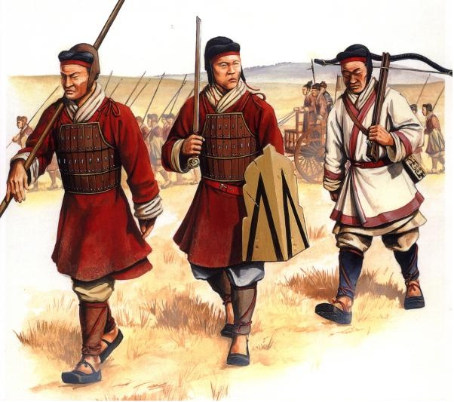
Selection from the Confucian Analects: On War
13:29 The Master [Confucius] said, “When a good man has taught the common people for seven years, they should be ready to be employed in war.”
13:30 The Master said, “To lead the people to war without having taught them is to throw them away.”

Questions:
1) What is Confucius’ attitude toward war?

2) What do these excerpts indicate about Confucius’ understanding of the relationship between the ruler and his people?

Selected Document Excerpt with Questions From Sources of Chinese Tradition, compiled by Wm. Theodore de Bary and Irene Bloom, 2nd ed., vol. 1 (New York: Columbia University Press, 1999), 57. © 1999 Columbia University Press. Reproduced with the permission of the publisher. All rights reserved.
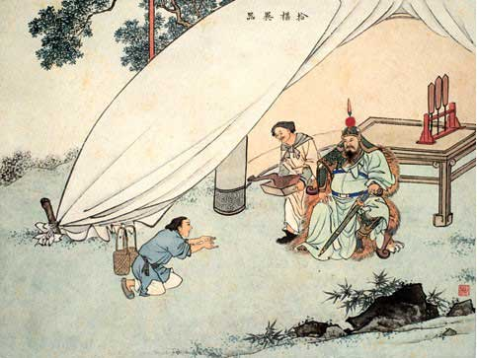
Selection from the Confucian Analects: On Women and Servants
17:25 Women and servants are most difficult to nurture. If one [person] is close to them, they lose their composure [self-control], while if one is distant, they feel resentful [offended].

Questions:
1) What point of view does Confucius reveal in this statement?

2) Why do you think he puts women and servants in the same category?

3) What does this passage reveal about class structure and class stereotypes in Confucius’ time?

4) Can you find parallels to Confucius attitude in other cultures at the same or at other times?
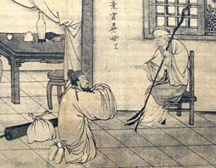
Selection from the Confucian Analects: On Filial Piety
1:11 The Master [Confucius] said, “When a person’s father is alive, observe his intentions. After his father is no more, observe his actions. If for three years he does not change his father’s ways, he is worthy to be called filial [loving].”

Questions:
1) As Confucius sees it, what qualities might there be in the ideal relationship between a man and his son?

2) What effect would this definition of filial piety have on your life, if you were to follow it? What effect do you think it would have had on the lives of men in imperial China?

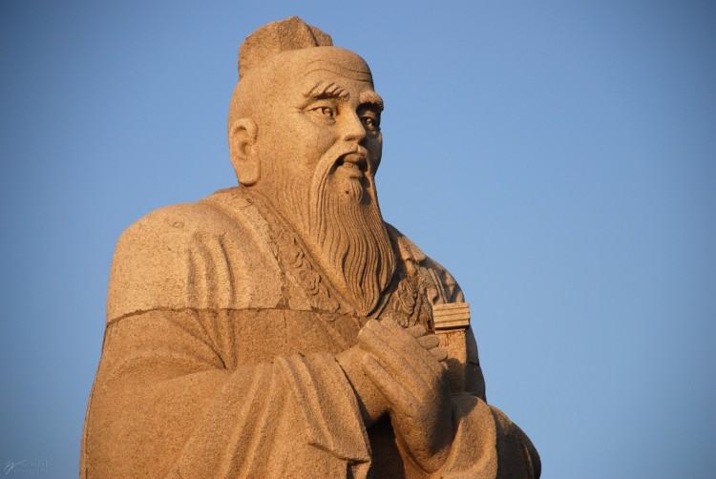
Selections from the Confucian Analects: On Humaneness
4:5 The Master [Confucius] said, “Wealth and honor are what people desire, but one should not abide in them if it cannot be done in accordance with the Way. Poverty and lowliness are what people dislike, but one should not avoid them if it cannot be done in accordance with the Way. If the noble person rejects humaneness, how can he fulfill that name? The noble person does not abandon humaneness for so much as the space of a meal. Even when hard‐pressed he is bound to it, bound to it even in time of danger.”
6:28 Zigong said, “What would you say of someone who broadly benefited the people and was able to help everyone? Could he be called humane?” The Master said, “How would this be a matter of humaneness? Surely he would have to be a sage [wise man]? Even Yao and Shun were concerned about such things. As for humaneness — you want to establish yourself; then help others to establish themselves. You want to develop yourself; then help others to develop themselves. Being able to recognize oneself in others, one is on the way to being humane.”1
12:22 Fan Chi asked about humaneness. The Master [Confucius] said, “It is loving people.” He asked about wisdom. The Master said, “It is knowing people.” When Fan Chi did not understand, the Master said, “Raise the upright, put them over the crooked [evil], and you should be able to cause the crooked to become upright.”

Questions:
1) What kind of quality or virtue is jen or humaneness, and what kind of person could be called a person of humaneness?

2) Do you find any similarities between the humaneness of Confucius and the guiding principles of another religious tradition with which you may be familiar — for example, love or charity in Christianity, social responsibility in Judaism, or compassion in Buddhism? Any differences?

3) Can relationships within a family be based on the concept of humaneness (humanity)? Can a government be based on the same concept?

4) How does Confucius’ concept of humaneness compare to the way in which philosophers such as Han Fei and Lord Shang [legalism thinkers] think about human beings and human society?

Introduction
Confucius (the Latinized version of Kong Fuzi, “master Kong”) or, to call him by his proper name, Kong Qiu (551-479 BCE) lived during the time when the Zhou kingdom had disintegrated into many de facto independent feudal states which were subject to the Zhou kings only in theory. Confucius was a man of the small feudal state of Lu. Like many other men of the educated elite class of the Eastern Zhou, Confucius traveled among the states, offering his services as a political advisor and official to feudal rulers and taking on students whom he would teach for a fee. Confucius had an unsuccessful career as a petty bureaucrat, but a highly successful one as a teacher. A couple of generations after his death, first- and second-generation students gathered accounts of Confucius’ teachings together. These anecdotes and records of short conversations go under the English title of the Analects. The selections below illustrate Confucius as a teacher and as a person.
Document Excerpts with Questions (Longer selection follows this section) From Sources of Chinese Tradition, compiled by Wm. Theodore de Bary and Irene Bloom, 2nd ed., vol. 1 (New York: Columbia University Press, 1999), 44-63. © 1999 Columbia University Press. Reproduced with the permission of the publisher. All rights reserved.
Selections from the Confucian Analects: On Confucius as a Teacher and Person
2:4 The Master said, “At fifteen, my heart was set upon learning; at thirty, I had become established; at forty, I was no longer perplexed; at fifty, I knew what is ordained by Heaven;1 at sixty, I obeyed; at seventy, I could follow my heart’s desires without transgressing the line.”
7:8 The Master said, “To one who is not eager I do not reveal anything, nor do I explain anything to one who is not communicative. If I raise one corner for someone and he cannot come back with the other three, I do not go on.”
1 In Chinese, tianming, also translated in other contexts as the Mandate of Heaven. 2 The identity of “our old Peng” is unclear, but he is usually taken to be the Chinese counterpart to Methuselah.
7:15 The Master said, “Having coarse rice to eat, water to drink, a bent arm for a pillow ‐‐ joy lies in the midst of this as well. Wealth and honor that are not rightfully gained are to me as floating clouds.”
7:21 The Master said, “Walking along with three people, my teacher is sure to be among them. I choose what is good in them and follow it and what is not good and change it.”
15:38 The Master said, “In education there should be no class distinctions.”

Questions:
1) What qualities of Confucius do you think might have made him a good teacher? Do you think he would still be considered a good teacher if he were alive today in our own society? Why or why not?

2) What qualities do you think Confucius would look for in an educated person?

3) Was Confucius an egalitarian or an elitist? How do you know?

4) What is Confucius’ attitude toward life and toward himself

