City-States
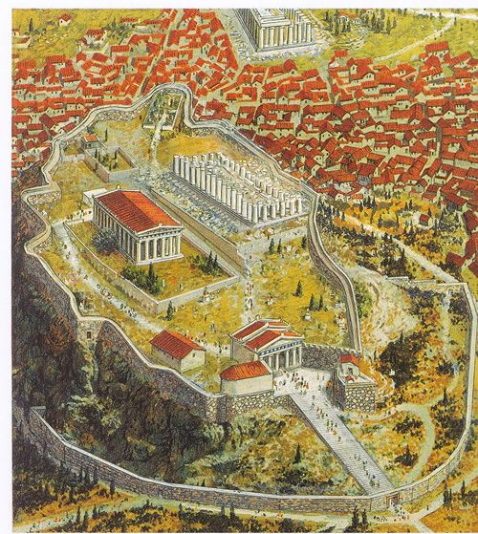
A polis [city-state] (plural: poleis) was the typical structure of a community in the ancient Greek world. A polis consisted of an urban center, often fortified and with a sacred center built on a natural acropolis [hill] or harbor, which controlled a surrounding territory. The term polis has, therefore, been translated as ‘city-state’ as there was typically only one city and because an individual polis was independent from other poleis in terms of political, legal, religious and social institutions and practices, each polis was in effect a state. Like a state, each polis was also involved in international affairs, both with other poleis and non-Greek states in the areas of trade, political alliances and wars.
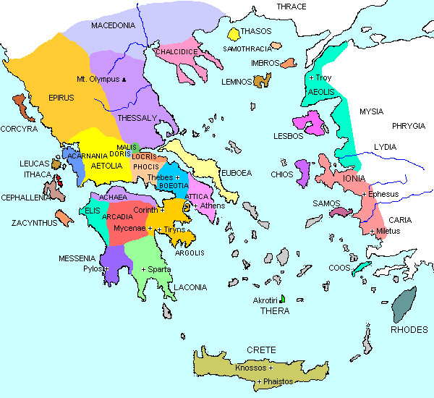
COMMON FEATURES
Although individual poleis each had their own particular identity and individual institutions and practices differed widely and even evolved over time, there were several features common to the majority. Most of the population of a polis lived in the city rather than being spread across small farm communities in the surrounding territory and the heart of the urban area was usually a sacred space with one or more temples. From the 8th century BCE these were almost always the most impressive buildings in the polis [city]... From the 7th century BCE the city was usually fortified with a city wall and the agora [market] space was created for civic and commercial activity... Many poleis also had a designated space for public assembly, either for political purposes or also for entertainment, for example, a theatre and a gymnasium.
A fundamental idea common to most poleis [city-states] was that all male citizens had (at least theoretically) equal political rights based on ownership of property. In practice, whatever the political system adopted - tyranny [dictatorship], oligarchy [power in the hands of a few] or democracy [power in the hands of the many by voting] - political power was dominated by a few aristocratic [noble] families who held for themselves all the important positions in the polis such as membership of elite councils, magistracies and the higher military ranks.
Other more practical indicators of the polis as a separate unit were boundary markers, written law-codes, coinage using specific imagery related to the polis’ history, wars - where soldiers fought a common enemy, often to settle disputed territorial claims, and the production of distinctive goods. A common community history or ‘civic memory’ was reinforced and commemorated in public statues of local gods, leaders, benefactors and sporting champions. Finally, the polis founded colonies abroad, especially in Magna Graecia and Ionia and became a ‘mother’ city and provided both a symbolic transfer of identity and a practical transfer of people and community skills (e.g. potters and metal workers). Many of these colonies were founded because of population pressure from home (overpopulation) and a need for resources beyond those available in Greece, particularly agricultural resources.

Adapted from Ancient Encyclopedia

QUESTIONS
1) What other cultures have we studied that also had city-states? How did their government systems work?

2) What are some of the defining features of a city-state? List them in order of importance 1-X.

3) What were the various government structures a city-state could have? Which would you have preferred to rule a city-state? Why?

4) Why did Greek city-states create colonies overseas?

