Name:__________________________________________________ Date:______________________
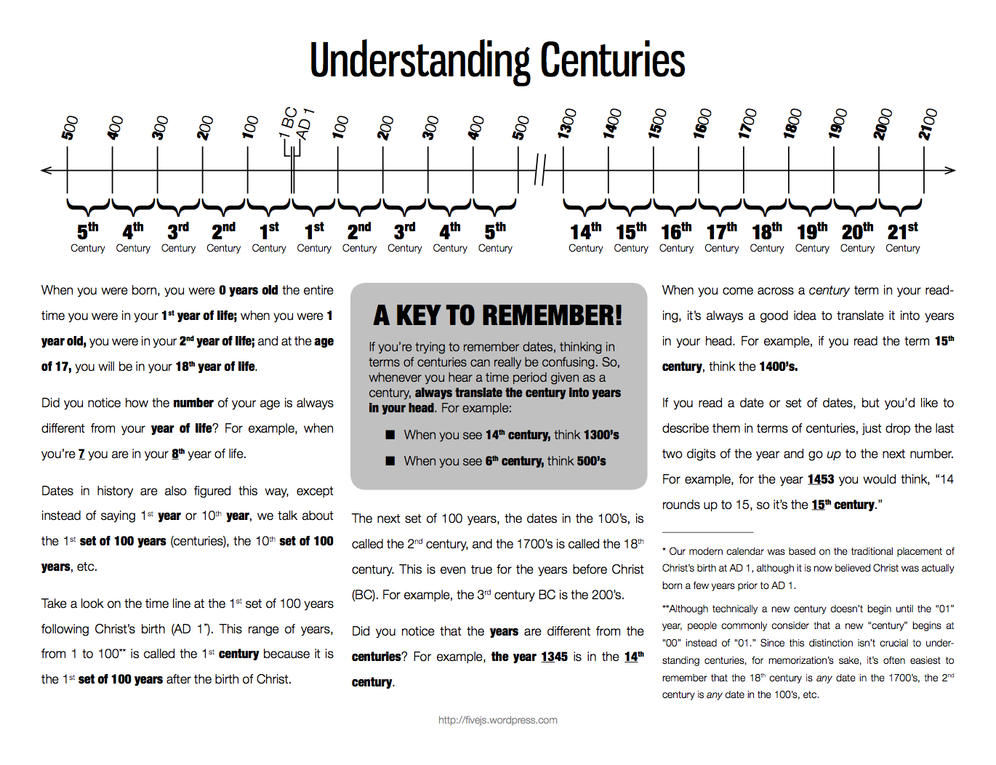
Ms. Scotto, Global 1 Centuries & Dating

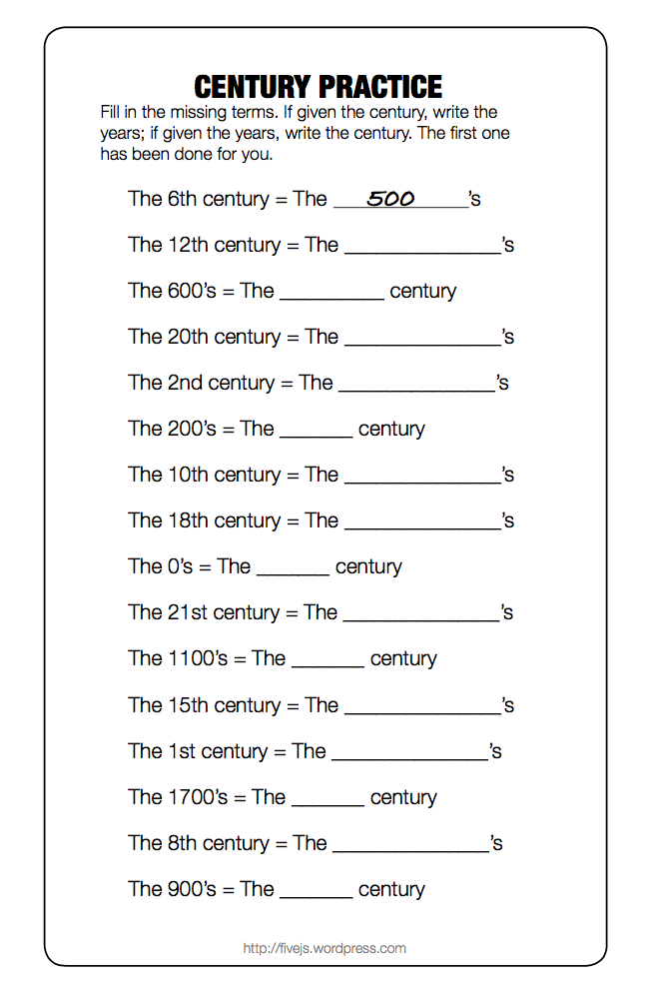
Directions: Watch the following video on BC & AD Dating, and answer the following questions.

- Who was the first civilization to establish a dating system?

- When and who developed our current dating system?

- What does BC stand for? What does AD stand for?

- Why is AD placed before the number? Why is BC placed after the number?

- What is the common misconception associated with AD? Why is it incorrect?

- How does the dating system resemble a number line?

- What abbreviations can also be used for BC and AD? Why is it used?

Directions: Plot these events chronologically on the accompanying timeline.

Han Dynasty: 206 BC- AD 220
Delhi Sultanate: AD 1206-1526
Fall of Roman Empire: CE 476
Agricultural Revolution: 8000 BC
Mansa Musa’s Reign in Mail Begins: CE 1307
Life of Jesus: 4 BCE – 29 CE
Hammurabi’s Code: 1775 BCE
Aztec Empire: AD 1325-1521
Phoenicians Develop Alphabet: 1100 BC
Protestant Reformation Begins: CE 1517
