**How the Byzantine Empire Influences**

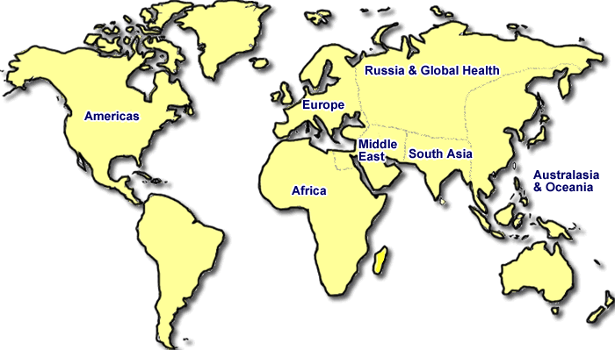**a developing Russian Civilization**

When Constantinople fell to the Ottoman Turks in 1453, Russian princes in Moscow claimed, “a new and third Rome has sprung up in the north.”

This ‘third Rome’ was Moscow, the capital of Russia.

Was Russia the next Rome? Did Russia continue the Byzantine legacy?

**Byzantine Influence on Russian Language:** Trade had already brought Byzantine ideas into Kiev, the capital of Russia. Constantinople later sent Christian missionaries to convert the Slavs (another name for the Russian people). About 863, two Greek monks from the Byzantine Empire, Cyril and Methodius, adapted the Greek alphabet so they could translate the bible into Slavic languages. This Cyrillic alphabet became the written language used in Russia and the Ukraine up to today.

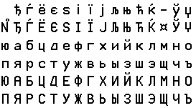

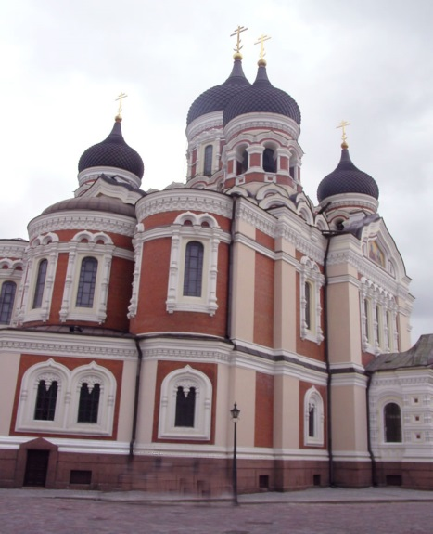**Byzantine influence on Russian Religion- Orthodox Christianity:** Byzantine missionaries spread Orthodox Christianity to Russia and other countries of Eastern Europe. A prince of Moscow, Vladimir, even had all the citizens of Kiev baptized in the Dnieper River. Along with Christianity the Russians also adapted Byzantine religious art, music, and architecture. Byzantine domes were adapted by the Russians and made into colorful, carved “helmets.” The domes of Russian churches became known as onion domes.

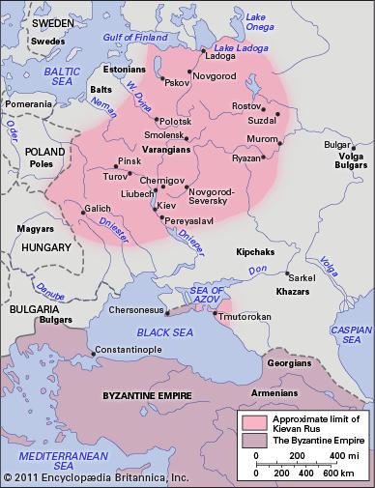

Even today, the Orthodox Christian faith remains a powerful force through much of the region.

**Byzantine Influence on Russian Rulers or Czars:** A Ruler of Russia is called a Czar (the Russian word for Caesar, Rome’s great emperor). Typically the czar is an autocrat or has complete control over both the government and the church. Rulers control the church by making the church dependent on the government for funds. Byzantine rulers were also autocrats, controlling both the state and the church.

Kiev enjoyed its golden age under Yaroslav the Wise, who ruled from 1019 to 1054. To improve justice, he set up a written code of laws. A scholar, he translated Greek works into his own language, thereby preserving Greek culture.

*QUESTIONS*

* 1. What did Byzantine monks create for Russian Civilization? Why did they do this?
  2. Describe how the Russians adapted Byzantine architecture.
  3. Why is a Russian Ruler called a czar?
  4. Why did Czars become autocrats?
  5. Does Moscow deserve to be called the 3rd Rome? Explain your answer.