Byzantine Empire
The Byzantine Empire was the continuation of the Roman Empire in the Greek-speaking, eastern part of the Mediterranean. Christian in nature, it was often at war with the Muslims, flourishing during the reign of the Macedonian emperors, its demise was the consequence of attacks by Seljuk Turks, Crusaders, and Ottoman Turks.
CHRISTIANITY
In the course of the fourth century, the Roman world became increasingly Christian, and the Byzantine Empire was certainly a Christian state. It was the first empire in the world to be founded not only on worldly power, but also on the authority of the Church. Paganism, however, stayed an important source of inspiration for many people during the first centuries of the Byzantine Empire.
When Christianity became organized, the Church was led by five patriarchs, who resided in Alexandria, Jerusalem, Antioch, Constantinople, and Rome. The Council of Chalcedon (451 CE) decided that the patriarch of Constantinople was to be the second in the ecclesiastical hierarchy. Only the pope in Rome was his superior. After the Great Schism of 1054 CE the eastern (Orthodox) church separated form the western (Roman Catholic) church. The center of influence of the orthodox churches later shifted to Moscow.
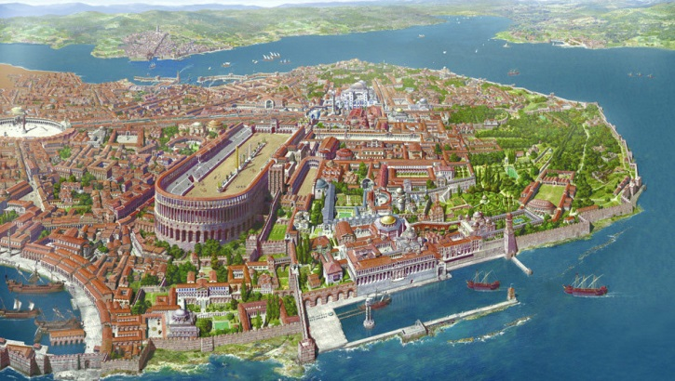
CULTURAL LIFE
The Byzantine Empire was quite modern. Its tax system and administration were so efficient that the empire survived more than a thousand years.
The culture of Byzantium was rich and affluent, while science and technology also flourished. Very important for us, nowadays, was the Byzantine tradition of rhetoric and public debate. Philosophical and theological discources were important in public life, even emperors taking part in them. The debates kept knowledge and admiration for the Greek philosophical and scientific heritage alive. Byzantine intellectuals quoted their classical predecessors with great respect, even though they had not been Christians. And although it was the Byzantine emperor Justinian who closed Plato's famous Academy of Athens in 529 CE, the Byzantines are also responsible for much of the passing on of the Greek legacy to the Muslims, who later helped Europe to explore this knowledge again and so stood at the beginning of European Renaissance.
Ancient Encyclopedia
MACEDONIAN DYNASTY
The second period in Byzantine history consists of its highest point. It fell during the Macedonian dynasty (867-1057 CE). After an age of contraction, the empire expanded again and in the end, almost every Christian city in the East was within the empire's borders. On the other hand, wealthy Egypt and large parts of Syria were forever lost, and Jerusalem was not reconquered.
In 1014 CE the mighty Bulgarian empire, which had once been a very serious threat to the Byzantine state, was finally overcome after a bloody war, and became part of the Byzantine Empire. The victorious emperor, Basil II, was surnamed Boulgaroktonos, "Slayer of Bulgars". The northern border now was finally secured and the empire flourished.
Throughout this whole period the Byzantine currency, the nomisma, was the leading currency in the Mediterranean world. It was a stable currency ever since the founding of Constantinople. Its importance shows how important Byzantium was in economics and finance.
Constantinople was the city where people of every religion and nationality lived next to one another, all in their own quarters and with their own social structures. Taxes for foreign traders were just the same as for the inhabitants. This was unique in the world of the middle ages.
CRISIS
Despite these favorable conditions, Italian cities like Venice and Amalfi, gradually gained influence and became serious competitors. Trade in the Byzantine world was no longer the monopoly of the Byzantines themselves. Fuel was added to these beginning trade conflicts when the pope and patriarch of Constantinople went separate ways in 1054 CE (the Great Schism).
Decay became inevitable after the Battle of Manzikert in 1071 CE. Here, the Byzantine army under the emperor Romanus IV Diogenes, although reinforced by Frankish mercenaries, was beaten by an army of the Seljuk Turks, commanded by Alp Arslan ("the Lion"). Romanus was probably betrayed by one of his own generals, Joseph Tarchaniotes, and by his nephew Andronicus Ducas.
After the battle, the Byzantine Empire lost Antioch, Aleppo, and Manzikert, and within years, the whole of Asia Minor was overrun by Turks. From now on, the empire was to suffer from manpower shortage almost permanently. In this crisis, a new dynasty, the Comnenes, came to power. To obtain new Frankish mercenaries, emperor Alexius sent a request for help to pope Urban II, who responded by summoning the western world for the Crusades. The western warriors swore loyalty to the emperor, reconquered parts of Anatolia, but kept Antioch, Edessa, and the Holy Land for themselves.

DECLINE & FALL
For the Byzantines, it was increasingly difficult to contain the westerners. They were not only fanatic warriors, but also shrewd traders. In the twelfth century, the Byzantines created a system of diplomacy in which deals were concluded with towns like Venice that secured trade by offering favorable positions to merchants of friendly cities.
Soon, the Italians were everywhere, and they were not always willing to accept that the Byzantines had a different faith. In the age of the Crusades, the Greek Orthodox Church could become a target of violence too. So it could happen that Crusaders plundered the Constantinople in 1204 CE. Much of the loot can still be seen in the church of San Marco in Venice.
For more than half a century, the empire was ruled by monarchs from the West, but they never succeeded in gaining full control. Local rulers continued the Byzantine traditions, like the grandiloquently named "emperors" of the Anatolian mini-states surrounding Trapezus, where the Comnenes continued to rule, and Nicaea, which was ruled by the Palaiologan dynasty.
The Seljuk Turks, who are also known as the Sultanate of Rum, benefited greatly of the division of the Byzantine Empire, and initially strengthened their positions. Their defeat, in 1243 CE, in a war against the Mongols, prevented them from adding Nicaea and Trapezus as well. Consequently, the two Byzantine mini-states managed to survive.
The Palaiologans even managed to capture Constantinople in 1261 CE, but the Byzantine Empire was now in decline. It kept losing territory, until finally the Ottoman Empire (which had replaced the Sultanate of Rum) under Mehmet II conquered Constantinople in 1453 CE and took over government. Trapezus surrendered eight years later.
ARTISTIC LEGACY
After the Ottoman take-over, many Byzantine artists and scholars fled to the West, taking with them precious manuscripts. They were not the first ones. Already in the fourteenth century, Byzantine artisans, abandoning the declining cultural life of Constantinople, had found ready employ in Italy. Their work was greatly appreciated and western artists were ready to copy their art. One of the most striking examples of Byzantine influence is to be seen in the work of the painter Giotto, one of the important Italian artists of the early Renaissance.

