Name: Date:
Global History 9H Mr. Lipari
ANCIENT ATHENS
The city of Athens, Greece, with its famous Acropolis (see picture below), has come to symbolize the whole of the country in the popular imagination, and not without cause. Athens began as a small, Mycenaen community and grew to become a city that, at its height, showed the best of Greek virtues and enjoyed such prestige that the Spartans refused to destroy the city or enslave the citizens, even after Athens' defeat in the Peloponnesian War. This set a model that would be followed by future conquerors who would defeat Athens but not destroy it.

EARLY SETTLEMENT
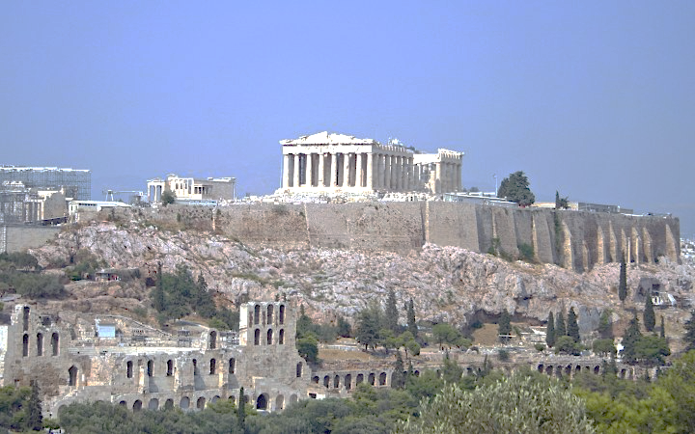
Evidence of human habitation on the Acropolis and, below, in the area around the Agora, dates back clearly as far as 5000 BCE and, probably, as early as 7000 BCE. As the soil was not favorable to large-scale agricultural programs, Athens turned to trade for its livelihood and, mainly, to sea trade. They became expert traders over the centuries and greatly benefited from the taxes levied on trade.

ATHENIAN GOVERNMENT & LAWS
According to the historian Waterfield, "The pride that followed from widespread involvement in public life gave Athenians the energy to develop their city both internally and in relation to their neighbors". This new form of government would provide the stability necessary to make Athens the cultural and intellectual center of the ancient world; a reputation which lasts even into the modern age.

THE GOLDEN AGE
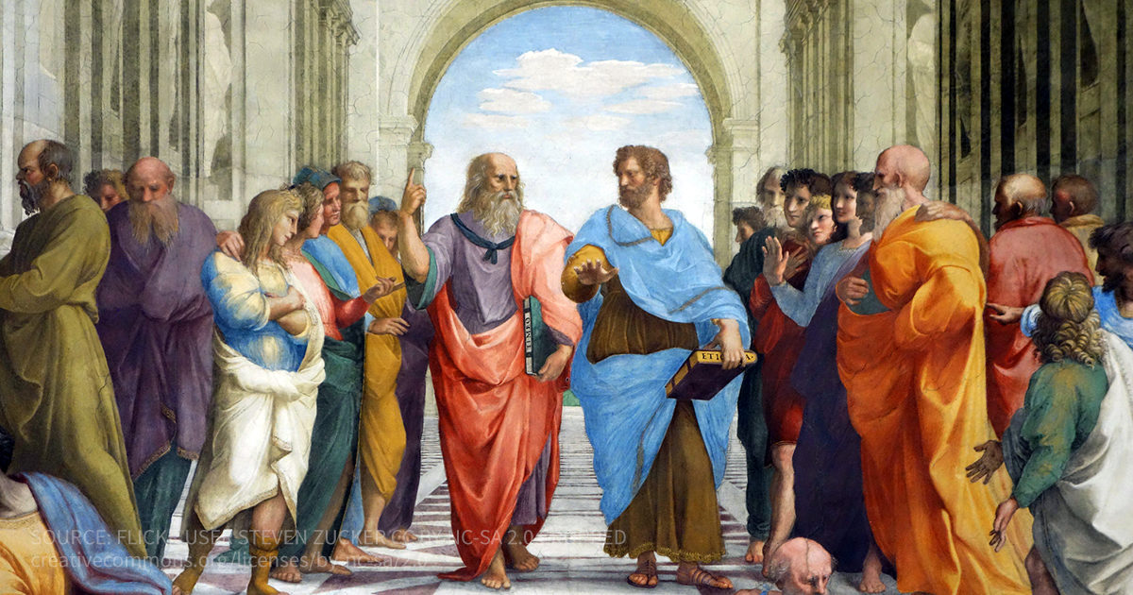
Under the leader Pericles during the 5th century BCE< Athens entered her golden age and great thinkers, writers, and artists flourished in the city. Herodotus, the `father of history', lived and wrote in Athens. Socrates, the `father of philosophy', taught in the marketplace. Hippocrates, `the father of medicine', practiced there. The sculptor Phidias created his great works for the Parthenon on the Acropolis and the Temple of Zeus at Olympia. Democritus envisioned an atomic universe This legacy would continue as, later, Plato would found his Academy outside the walls of Athens in 385 BCE and, later, Aristotle's Lyceum would be founded in the city center.

The might of the Athenian Empire (specifically its navy, the best in all of Greece) encouraged an arrogance in the policy makers of the day which grew intolerable to her neighbors.

The Peloponnesian War (431-404 BCE) between Athens and Sparta (involving, directly or indirectly, all of Greece) ended in disaster for Athens after her defeat. Her empire and her wealth gone, her walls destroyed, only her reputation as a great seat of learning and culture prevented the destruction of the city and the enslavement of the populace. Athens struggled to throw off her condition as a subject state, and with some success, until they were defeated in 338 BCE by the Macedonian forces under Philip II.

THE INSTITUTIONS OF DEMOCRACY
Most famously, Athens gave the world its first democracy. Any male citizen could participate in the main democratic body of Athens, the assembly (ekklēsia). In the 4th and 5th centuries BCE the male citizen population of Athens ranged from 30,000 to 60,000 depending on the period. Any citizen could speak to the assembly and vote on decisions by simply holding up their hands. The majority won the day and the decision was final.

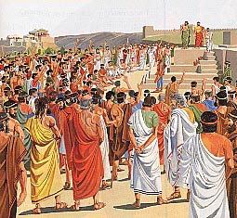
PARTICIPATION IN GOVERNMENT
Only male citizens who were 18 years or over could speak (at least in theory) and vote in the assembly, while positions such as magistrates and jurors were limited to those over 30 years of age. Therefore, women, slaves, and resident foreigners (metoikoi) were excluded from the political process.
Citizens probably accounted for 10-20% of the polis population, and of these it has been estimated that only 3,000 or so people actively participated in politics. Of this group, perhaps as few as 100 citizens - the wealthiest, most influential, and the best speakers - dominated the political arena both in front of the assembly and behind the scenes in private political meetings and groups. Men and women were treated unequally; welathy boys learned to read, write, play sports, compose poetry, play music, while girls were left to learn weaving, spinning, and other domestic tasks. Furthermore, wives were considered to be the property of their husbands.

CONCLUSION
In the words of historian K. A. Raaflaub, democracy in ancient Athens was
a unique and truly revolutionary system that realized its basic principle to an unprecedented and quite extreme extent: no polis [city] had ever dared to give all its citizens equal political rights, regardless of their descent, wealth, social standing, education, personal qualities, and any other factors that usually determined status in a community.
Ideals such as these would form the cornerstones of all democracies in the modern world. The ancient Greeks have provided us with fine art, breath-taking temples, timeless theatre, and some of the greatest philosophers, but it is democracy which is, perhaps, their greatest and most enduring legacy.
Adapted from Ancient Encyclopedia-Ancient Athens

