Leeds Woolen Workers Petition, 1786
This petition by workers in Leeds (a major center of wool manufacture in Yorkshire) appeared in a local newspapers in 1786. They are complaining about the effects of machines on the previously well-paid skilled workers.
To the Merchants, Clothiers and all such as wish well to the Staple Manufactory of this Nation.
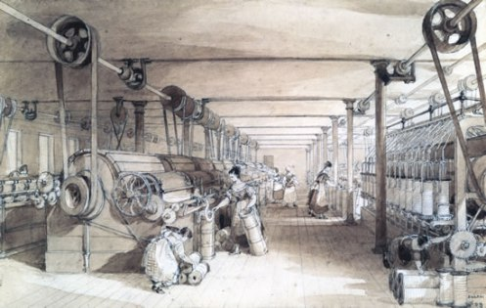
The Humble ADDRESS and PETITION of Thousands, who labor in the Cloth Manufactory.
The Machines have thrown thousands... out of employment... and are not able to procure a salary for their families, and deprived them of the opportunity of bringing up their children to labor.
The number of Machines... [are] no less than one hundred and seventy! and as each machine will do as much work in twelve hours, as ten men can in that time do by hand, and they working night-and day, one machine will do as much work in one day as would otherwise employ twenty men.
As we do not mean to assert anything but what we can prove to be true, we allow four men to be employed at each machine twelve hours, working night and day, will take eight men in twenty-four hours... twelve men are thrown out of employ for every single machine used... full four thousand men are left to shift for a living how they can, and must of course fall to the Parish [town], if not timely relieved.
We therefore hope, that the feelings of humanity will lead those who have it in their power to prevent the use of those machines, to give every discouragement they can to what has a tendency so harmful to their fellow man.
Men of common sense must know, that so many machines in use, take the work from the hands employed... and who did that business before machines were invented?
***How are those men, thus thrown out of employ to provide for their families; - and what are they to put their children apprentice to, that the rising generation may have something to keep them at work, in order that they may not be like vagabonds [homeless] strolling about in idleness? Some say, "Begin and learn some other business." - Suppose we do; who will maintain our families, while we undertake the arduous [difficult] task; and when we have learned it, how do we know we shall be any better for all our pains; for by the time we have served our second apprenticeship, another machine may arise, which may take away that business...
Signed, in behalf of THOUSANDS, by J. H. T. Lobley and Robert Wood Thos. Blackburn
From J. F. C. Harrison, Society and Politics in England, 1780-1960 (New York: Harper & Row, 1965), pp. 71-72.

QUESTIONS
1) How many men are unemployed by each scribbling machine?

2) What problems are caused using these machines? List at least three.

3) What is the solution these workers propose? What solution would you propose?

