ANCIENT EGYPT
Geography

The Nile

Natural Barriers

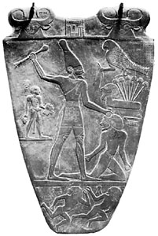
Government

Pharaohs and Dynasties

Administration and Expansion

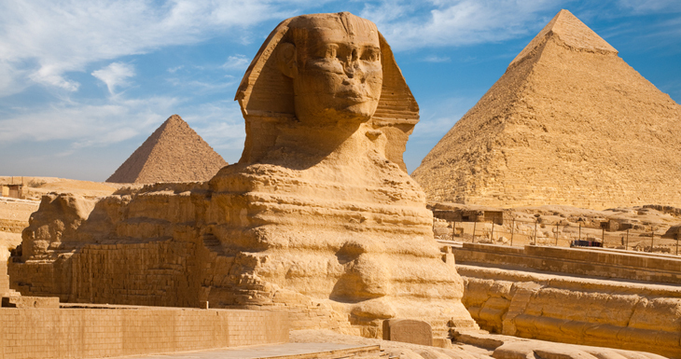
Cultural Achievements
Monumental Architecture

Religion

Hieroglyphics and Papyrus

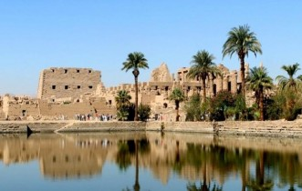
Economy

Agriculture

Trade

