Abbé Sieyes: What is the Third Estate?

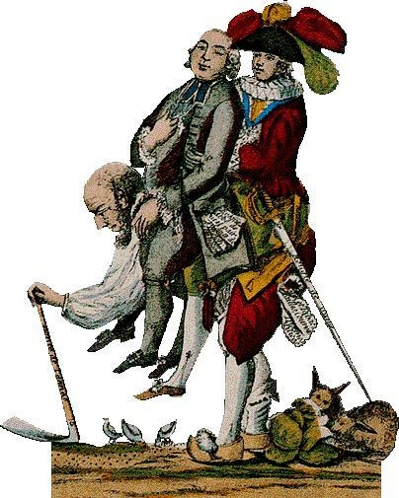
Emmanuel Joseph Sieyes: "What is the Third Estate? [Edited Excerpts]
The Third Estate attends to nineteen-twentieths of [the burdens of society], with this distinction; that it is laden with all that which is really painful, with all the burdens which the privileged classes [nobles and clergy] refuse to carry. Do we give the Third Estate credit for this?... They [the nobles and clergy] have said to the Third Estate: "Whatever may be your services, whatever may be your abilities, you shall go thus far; you may not pass beyond!" Certain rare exceptions [when individuals can rise beyond their social class], properly regarded, are but a mockery...
It suffices here to have made it clear that the pretended utility [usefulness] of a privileged order for the public service is nothing more than a chimera [a distraction]; that with it all that which is burdensome in this service is performed by the Third Estate; that without it the superior places would be infinitely better filled [by skilled individuals]...
Who then shall dare to say that the Third Estate has not within itself all that is necessary for the formation of a complete nation? It is the strong and robust man who has one arm still shackled. If the privileged order should be abolished, the nation would be nothing less, but something more. Therefore, what is the Third Estate? Everything; but an everything which is shackled and oppressed. What would the nation be without the privileged order? Everything, but an everything free and flourishing. Nothing can succeed without it, everything would be infinitely better without the others.
It is not sufficient to show that privileged persons, far from being useful to the nation, cannot but enfeeble and injure it; it is necessary to prove further that the noble order does not enter at all into the social organization; that it may indeed be a burden upon the nation, but that it cannot of itself constitute a nation.
What is a nation? A body of associates, living under a common law, and represented by the same legislature, etc.
Is it not evident that the noble order has privileges and expenditures which it dares to call its rights, but which are apart from the rights of the great body of citizens? It departs there from the common law. So its civil rights make it an isolated people in the midst of the great nation...
The Third Estate embraces then all that which belongs to the nation; and all that which is not the Third Estate, cannot be regarded as being of the nation.
What is the Third Estate?
It is the whole.
QUESTIONS
1) In your own words, what is the Third Estate?

2) What is the author's view of the nobility, the "privileged class" as he calls them?
How is this a divergence from all of past history?

3) Why does the author claim that the privileged class is not a part of the nation? (Hint: how does he define a nation?)

4) What do you think is a solution to this problem of the Third Estate and privileged class?

