Maximilien Robespierre:
Justification of the Use of Terror

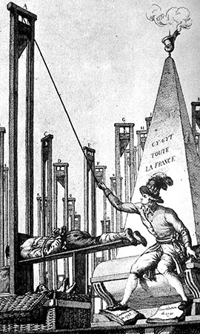
Maximilien Robespierre (1758 1794) was the leader of the twelve-man Committee of Public Safety elected by the National Convention, and which effectively governed France at the height of the radical phase of the revolution. He had once been a fairly straightforward liberal thinker - reputedly he slept with a copy of Rousseau's Social Contract at his side. But his own purity of belief led him to impatience with others.
The committee directed its energies against counter-revolutionary uprisings, especially in the south and west of France. In doing so it unleashed the reign of terror. Here Robespierre, in his speech of February 5,1794, from which excerpts are given here, discussed this issue.
Robespierre was frustrated with the progress of the revolution. After issuing threats to the National Convention, he himself was arrested in July 1794. He tried to shoot himself but missed, and spent his last few hours with his jaw hanging off. He was guillotined, as a victim of the terror, on July 28, 1794.
We must suffocate the internal and external enemies of the Republic [France] or perish with it; now in this situation, the first principle of your policy ought to be to lead the people by reason and the people's enemies by terror.
**If the source of popular government in time of peace is virtue, the sources of popular government in revolution are at once virtue and terror: virtue, without which terror is fatal; terror, without which virtue is powerless. Terror is nothing other than justice, prompt, severe, inflexible; it is therefore a production of virtue... **
It has been said that terror is the principle of despotic government [cruel dictatorship]. Does your government therefore resemble despotism? Yes, as the sword that shines in the hands of the heroes of liberty resembles that with which the henchmen of evil are armed… Reduce by terror the enemies of liberty, and you will be right, as founders of the Republic. The government of the revolution is liberty's despotism against tyranny. . .
This terrible war waged by liberty against tyranny- is it not the same? Are the enemies within not the allies of the enemies without... are all those men less guilty or less dangerous than the tyrants whom they serve?
Source: Robespierre: On the Moral and Political Principles of Domestic Policy
DEFINTION: Tyranny-a government in which absolute power is vested in a single ruler, usually oppressive

QUESTIONS
1) What does the term "virtue" mean to you? Can you be virtuous while using terror? Why/why not?

2) Is terror justified if it does good for the country at large? Why or why not? What does Robespierre say?

3) What is dangerous about Robespierre's views?

