9H World History Mr. Lipari

9H World History Course Syllabus

Introduction: Welcome to 9H World History and to Calhoun! I hope your four years here will be a great experience for each of you and I look forward to guiding you along the way. In this class, we will be examining and engaging with global phenomena and interactions across thousands of years of history. It will be a challenge, but you can all be successful in this class. Below is our roadmap for the class, which is here before you to provide a general outline of the course.
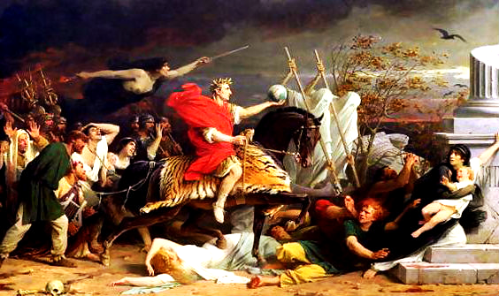

Julius Caesar-Crossing the Rubicon, 49 BCE

Grading Policy:

Homework and Quizzes (25% of grade) - It is your responsibility to check the board. Whenever possible, I will write the week's homework assignments on the board at the beginning of the week. Quizzes will be announced and unannounced.

Tests and Assessments (25%) - Tests will consist of a combination of short answer, multiple choice, and essay questions. I strongly recommended students attend extra help before all tests.
Classwork (50%) - This broad category includes attendance, written assignments in class, actual participation in class discussions, and compliance with school rules. Be seated when the bell rings, binders out, Do-Now and Aim copied onto loose-leaf. Respect yourself and others. Listen. Ask questions. Think critically.

Academic Honesty:
There is no tolerance for cheating. Cheating will result in a zero for the work in question.

Classroom Materials:
1) Binder, loose-leaf, 4 dividers (Classwork, homework, tests, AP Skills, etc.)
2) Folder
3) Pen, Pencil, Highlighter (with you every day)
4) Textbook: Voyages in World History / Valerie Hansen and Kenneth R. Curtis / Advanced Placement edition (to be left at home)
5) Bellmore-Merrick email account

Cellphones are to be put away or in the organizer in the room unless we are using them in class. If I see a phone, I will take the phone and hold on to it for the remainder of the period.

Absences- Students are responsible for all work. Contact either myself or a classmate to stay up to date and speak with me immediately if you miss a test or quiz.

AP Themes
1) Interactions between Humans and the Environment (ENV)
2) Development and Interaction of Cultures (CUL)
3) State Building, Expansion, and Conflict (SB)
4) Creation, Expansion, and Interaction of Economic Systems (ECON)
5) Development and Transformation of Social Structures (SOC)

Extra Help Hours:
Monday- 2:15-2:50, Room 102
Wednesday-2:15-2:50, Room 102

Teacher Email: mlipari@bellmore-merrick.k12.ny.us
Please contact me with questions you may have throughout the year or visit me during extra help hours.

Website: http://whap9hlipari.weebly.com
Files of our class assignments and homework will be posted for student access in case of absences, lost work, etc.

DUE SEPTEMBER 8th, 2017: I have read the syllabus and understand the standards expected for myself and my classmates:

Student Name (Print):

Student Name (Sign):

Parent/Guardian Name (Print):

Parent/Guardian Name (Sign):

****Be Advised****
I understand that history is not everyone's forte. But I would ask all of you, regardless of interest and ability, to think of our class and history more broadly as an epic tale of humankind. A tale that can help us better understand both ourselves and the world around us. It can shape our morality, mold our ideas, and sharpen our skills as we study it. And if you don't believe me, read a historian from 2,000 years ago saying the same idea:

"The study of history is the best medicine for a sick mind; for in history you have a record of the infinite variety of human experience plainly set out for all to see; and in that record you can find for yourself and your country both examples and warnings: fine things to take as models, base things, rotten through and through, to avoid."

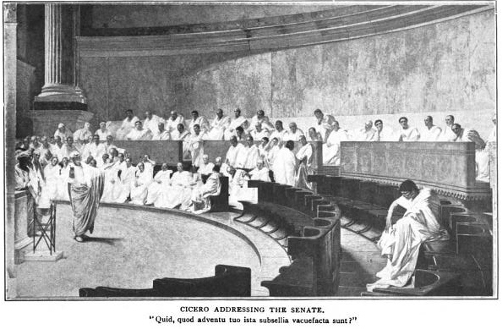
-Livy, Roman historian of the 1st century

