The Second Punic War

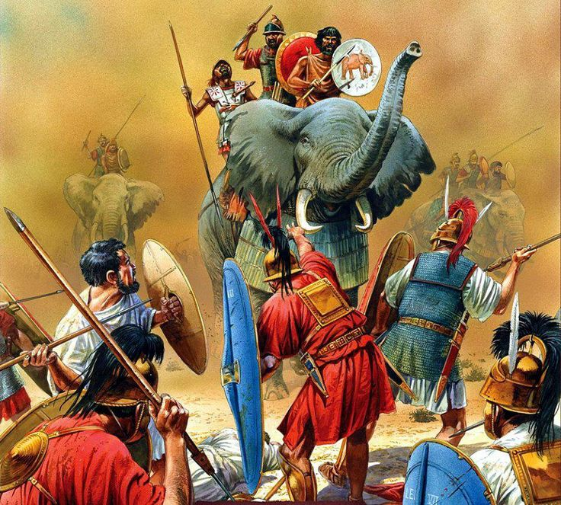
Second Punic War, also called Second Carthaginian War, second (218–201 BCE) in a series of wars between the Roman Republic and the Carthaginian (Punic) empire that resulted in Roman domination over the western Mediterranean.
In the years after the First Punic War, Rome seized Corsica and Sardinia from Carthage and forced Carthaginians to pay an even greater penalty than the payment exacted immediately following the war. Eventually, however, under the leadership of Hamilcar Barca, his son Hannibal, Carthage acquired a new base in Spain, where they could renew the war against Rome.
Because Rome controlled the sea, Hannibal led his army overland through Spain and Gaul and famously cross the Alps (with elephants). Roman troops tried to stop his advance but were outmatched, and Hannibal’s hold over northern Italy was established. In 217 Hannibal, reinforced by Gallic tribesmen, marched south. He won several battles but still refrained from attacking the city of Rome (he did not have the equipment, nor the amount of soldiers to take the city), even after annihilating a huge Roman army at Cannae in 216, the worst defeat Rome had ever suffered. But the Roman refused to surrender. A brilliant defensive strategy conducted by Quintus Fabius Maximus harassed the Carthaginians, and avoided true battle, as Hannibal was the better general. Thus, the two armies remained deadlocked on the Italian peninsula for years and the Romans continued to try and wear down Carthage.
Eventually, the Romans landed their own army at Carthage, and with his home city under threat, Hannibal retreated to North Africa and lost a close battle to the Romans. Roman persistence paid off and Rome was now the most powerful state in the Mediterranean Sea.

1) What led to the Second Punic War?

2) What did the Romans do, even when faced with impossible odds and constant defeat?

3) What does this passage demonstrate about the character of the Romans? Be specific.

