The First Punic War

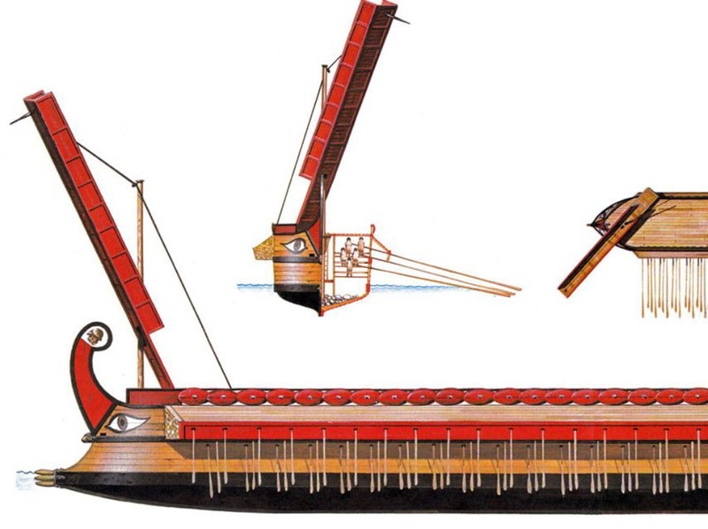
First Punic War, also called First Carthaginian War, (264–241 BCE) first of three wars between the Roman Republic and the Carthaginian (Punic) empire that resulted in the destruction of Carthage.
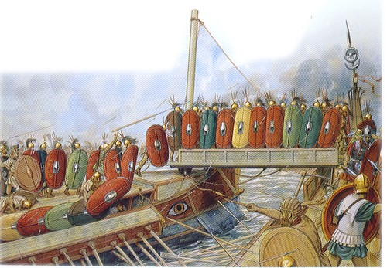
The First Punic War was fought to establish control over the strategic islands of Corsica and Sicily. In 264 the Carthaginians intervened in a dispute between the two principal Greek cities on the Sicilian east coast, Messana and Syracuse, and so established a presence on the island. Rome, responding to this challenge, attacked Messana and forced the Carthaginians to withdraw. This was Rome's first actions beyond Italy and did not go well to start with. Throughout this period, the Romans struggled to build and sail ships to get their troops to Sicily to fight Carthage. They were not natural sailors and lost many fleets in battle, partially because their ship design was inferior to that of Carthage's fleet. However, the Romans were an innovative people; they captured a Carthaginian ship, copied the design, rebuilt their fleet and even added a new invention: the corvus, which was a ramp on ships that allowed Roman soldiers to board enemy ships (see picture). This adaptation allowed the Romans to fight on their terms and helped them win the war. By 241 BCE, after 23 years of war, Rome finally defeated Carthage, seizing Sicily and Corsica and setting the scene for the 2nd Punic War.
QUESTIONS
1) What was the cause of the First Punic War?

2) How did the Romans adapt to fight the Carthaginians?

3) What does this passage demonstrate about the character of the Romans? Be specific.

