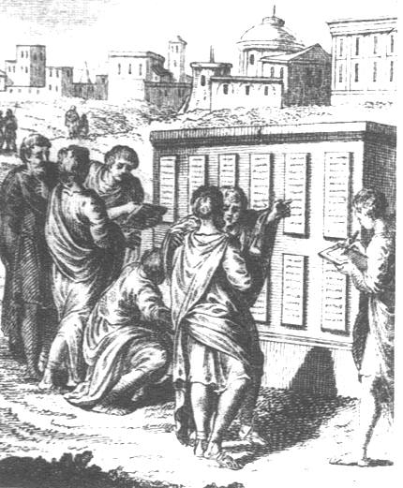
The Twelve Tables, c. 450 BCE
The Twelve Tables (aka Law of the Twelve Tables) was a set of laws inscribed on 12 bronze tablets created in ancient Rome in 451 and 450 BCE. They were the beginning of a new approach to laws where they would be passed by government and written down so that all citizens might be treated equally before them. Although not perhaps a fully codified system, it was a first step which would allow the protection of the rights of all citizens and permit wrongs to be redressed through precisely-worded written laws known to everybody. Consequently, the Roman approach to law would later become the model followed by many civilizations right up to the present day.
Table IV.
1. A dreadfully deformed child shall be quickly killed.
5. A child born after ten months since the father's death will not be admitted into a legal inheritance.
Table V.
1. Females should remain in guardianship [under their father] even when they have attained their majority [reached adulthood].
Table VIII.
2. If one has maimed a limb and does not compromise with the injured person, let there be retaliation. If one has broken a bone of a freeman with his hand or with a cudgel, let him pay a penalty of three hundred coins If he has broken the bone of a slave, let him have one hundred and fifty coins. If one is guilty of insult, the penalty shall be twenty-five coins.
3. If one is slain while committing theft by night, he is rightly slain.
4. If a patron shall have devised any deceit against his client, let him be accursed.
12. If the theft has been done by night, if the owner kills the thief, the thief shall be held to be lawfully killed.
23. A person who had been found guilty of giving false witness shall be hurled down from the Tarpeian Rock [executed].
26. No person shall hold meetings by night in the city.

Table IX.
4. The penalty shall be death for a judge or arbiter legally appointed who has been found guilty of receiving a bribe for giving a decision.
5. Treason: he who shall have roused up a public enemy or handed over a citizen to a public enemy must suffer capital punishment.
6. Putting to death of any man, whosoever he might be unconvicted of a crime is forbidden.
Table X.
3. The women shall not tear their faces nor wail on account of the funeral.
Table XI.
1. Marriages should not take place between plebeians [commoners, peasants] and patricians [aristocrats/nobles].
Although some scholars insist the Twelve Tables were not quite the ‘all equal before the law’ that tradition has claimed and that they were not enough alone to be defined as a complete law code, they set the foundation for what would become a system of fully codified law in the Roman world. The decemviri must also be credited with creating laws which were of practical value, separated from any religious consideration, visible to all, and outlined in precise language with explicit definitions. Thus, the Romans created an approach to legal matters which would be copied by countless other societies and governments ever since.

QUESTIONS
1) Why do societies create law systems?

2) What can we tell about Roman society based off these laws? What were their concerns, what were their values, etc.?

3) Was there equality between social classes and genders? Explain with evidence from the passage.

4) Why is it important to have laws written down and placed in public, for every Roman to see? Explain.

5) Which law do you find most important for society? Why? (Write down the table and law number)

The least important?

